PREPARATION OF
SUB-REGIONAL PLAN OF HARYANA SUB-REGION OF NCR-2021
INTERIM REPORT-1

CHAPTER – 1: INTRODUCTION
1.1 Background
The unprecedented growth of metropolitan cities in the country has become a source of serious concern to Government, on the one hand, and metro-city corporators, planners, demographers and social scientists, on the other. The Census 2001 reveals that the number of million-plus cities has almost tripled over the last three decades, jumping from a mere 12 in 1981 to 23 in 1991 and 35 in 2001. Interestingly, the aggregate population of these metro cities accounts for more than a third (37.81%) of the country’s total urban population, which is spread over more than 5,000 towns. It, therefore, goes without saying that these 35 metro (or million-plus) cities should be the focus of a sustained, country-wide effort to regulate and contain runaway urban growth by channelizing the flow and direction of economic growth (on which the urban phenomenon feeds) along more balanced and spatially-oriented paths. This is essentially what the National Capital Region (NCR) Planning Board is attempting to do with respect to the National Capital City.
The vast hinterland of the NCR, which lies mostly outside the Delhi Metropolitan Area (DMA) [now Central National Capital Region(CNCR)], continues to experience a very slow rate of economic development even while the core Sub-region of NCT-Delhi is witnessing a phenomenal surge of physical and economic growth. When we see the population trend of Delhi we find there is very high growth during last several decades. The decennial growth rate has been as high as 90% during 1941-51 and over 50% till 1981-91. Following table 1.1 shows the population of Delhi since 1901.
Table 1.1: Population trend of Delhi since 1901
Year | Total Delhi  Population | Percentage increase | Urban Population | Percentage increase | Rural Population | Percentage increase
1901 | 405819 | - | 214115 | - | 191704 | -
1911 | 413851 | 2.0 | 237944 | 11.13 | 175907 | -8.24
1921 | 488452 | 18.03 | 304420 | 27.94 | 184032 | 4.62
1931 | 636246 | 30.26 | 447442 | 46.98 | 188804 | 2.59
1941 | 917939 | 44.27 | 695686 | 55.48 | 222253 | 17.72
1951 | 1744072 | 90.00 | 1437134 | 106.58 | 306938 | 38.10
1961 | 2658612 | 52.44 | 2359408 | 64.17 | 299204 | -2.52
1971 | 4065698 | 52.93 | 3647023 | 54.57 | 418675 | 39.93
1981 | 6220406 | 53.00 | 5768200 | 58.16 | 452206 | 8.01
1991 | 9420644 | 51.45 | 8471625 | 46.87 | 949019 | 109.86
2001 | 13850507 | 47.02 | 12905780 | 52.34 | 944727 | -0.45
Source: Census of India 2001

1.2 Need of NCR Planning Board
The explosive rate of growth in its population has been a cause of serious concern to the government and all concerned city authorities. Efforts were made, in the past, through planned development and controls to contain the population of Delhi Metropolis. However, due to heavy influx of migration to Delhi from surrounding areas these efforts did not yield encouraging results. This population increase has heavily strained the infrastructural facilities and its resources. Therefore, it was felt necessary to invest in selected settlements outside the metropolis at appropriate distance and also, in impulse sectors to relieve Delhi of these pressure within a reasonable time frame. In order to prevent new pressures being generated and relieve Delhi from its present avoidable pressures it was felt that the planned growth of Delhi should be conceived only in a regional context. The need for Regional approach was felt as early as in 1959 when the draft Master Plan for Delhi was prepared. Thereafter the Master Plan of 1962 recommended that a statutory National Capital Region Planning Board should be set up for ensuring balanced and harmonized development of the region. Thereafter a statutory organization called “National Capital Region Planning Board” was set up in March 1985 under the National Capital Region Planning Board Act – 1985, to plan and promote the balanced and harmonized development of the Region comprising of Union Territory of Delhi; Meerut, Bulandshahar and Ghaziabad Districts of Uttar Pradesh; Faridabad, Gurgaon, Rohtak and Sonipat districts and Rewari tehsil of Mahendragarh district and Panipat tehsil of Karnal district of Haryana; and Alwar, Ramgarh, Behror, Mandawar, Kishengarh and Tijara tehsils of Alwar District in Rajasthan. The board in its 26th meeting held on 16.01.2004 approved the inclusion of additional areas comprising the remaining tehsils of Alwar district to NCR. Thus, the total area of the NCR increased to 33578 sq.km. in 2004 against 30242 Sq.Km. in 1986.
The NCR Planning Board has been formed keeping following objectives in mind:
1. Relieving the capital
2. Avoid adding new pressures on the capital and
3. Development of settlements in NCR to play their assigned role.
To achieve these objectives the draft Regional plan 2001 was prepared under section 10 of NCR Planning Board Act, 1985. The Regional Plan-2001, has suggested some strategies and programmes to achieve the objectives of balanced development of the region. In order to implement these programmes and policies, it is necessary to prepare the Sub-Regional Plan, Action Plans and Functions Plans for each sub-region.
1.3 Provisions for Sub-Regional plans
Under the provision of Section 17 of the NCRPB Act 1985 there is detailing of preparation of Sub-Regional plan, Section 19 of Act provides the directions for the submission of Sub-Regional plan to the board for the approval and Section 20 of Act provides for the implementation of Sub-Regional plans by each participating states.
1.4 Section 17 of NCRPB Act, 1985
Under this section there are following provisions:
1. Each participating State shall prepare a Sub-Regional Plan for the sub-region within that State and the Union territory shall prepare a Sub-Regional Plan for the sub-region within the Union territory.
2. Each Sub-Regional Plan shall be a written statement and shall be accompanied by such maps, diagrams, illustrations and descriptive matters as the participating State or the Union territory may deem appropriate for the purpose of explaining or illustrating the proposals contained in such Sub-Regional Plan and every such map, document, illustration and descriptive matter shall be deemed to be part of the Sub-Regional Plan.
3. A Sub-Regional Plan may indicate the following elements to elaborate the Regional Plan at the sub-regional level namely:-
a) reservation of areas for specific land-uses which are of the regional or sub-regional importance;
b) future urban and major rural settlements indicating their area, projected population predominant economic functions, approximate site and location;
c) road net-work to the district roads and roads connecting major rural settlements;
d) proposals for the co-ordination of traffic and transportation, including terminal facilities;
e) priority areas at sub-regional level for which immediate plans are necessary;
f) proposals for the supply of drinking water and for drainage; and
g) any other matter which is necessary for the proper development of the sub-region.
1.5 Section 19 of NCRPB Act, 1985
Under this section following provisions have been kept:
- Before publishing any Sub-Regional Plan, each participating State or, as the case may be, the Union territory, shall, refer such Plan to the Board to enable the Board to ensure that such Plan is in conformity with the Regional Plan.
- The Board shall, after examining a Sub Regional Plan, communicate within sixty days from the date of receipt of such Plan, its observations with regard to the Sub-Regional Plan to the participating State or the Union territory by which such Plan was referred to it.
- The participating State, or, as the case may be, the Union territory, shall, after due consideration of the observations made by the Board, finalize the Sub-Regional Plan after ensuring that it is in conformity with the Regional Plan.

1.6 Section 20 of NCRPB Act, 1985
Under this section it is given that each participating State, or, as the case may be, the Union territory shall be responsible for the implementation of the Sub-Regional Plan, as finalized by it under subsection (3) of section 19, and Project Plans prepared by it.
Under the above provision of NCR Planning Board Act, 1985, the draft Sub-Regional plan has been prepared for the Haryana Sub-Region of NCR.

CHAPTER 2: THE REGION

2.1 National Capital Region (NCR) Delhi
2.2 Constituent area of NCR
National capital region (NCR) constitutes of National Capital Territory Delhi and various parts of three states namely UP, Haryana and Rajasthan. The detailed description is shown in table (2.1):
Table 2-1: NCR Constituent descriptions

Sub-Region | Population  (2001) | Growth rate (%) | Population Density (Persons/Sq.Km.) | Area (Sq.Km.) | Area share to NCR (%) | Population share to NCR (%)
NCT Delhi | 13850507 | 47.02 | 9340 | 1483 | 4.41 | 37.33
Haryana | 8687050 | 30.76 | 648 | 13413 | 39.95 | 23.42
Rajasthan | 2992592 | 30.31 | 382 | 7829 | 23.32 | 8.06
UP | 11570117 | 28.53 | 1066 | 10853 | 32.32 | 31.19
NCR | 37100266 | 35.59 | 1105 | 33578 | 100.00 | 100.00
Census: Census of India 2001

2.2.1 General Profile
The NCR lies between 27º03’ and 29º29’ North latitude and 76º07’ and 78º29’ East longitude. The physiography of the region is characterized by the presence of the Ganga skirting it as its eastern boundary, the Yamuna traversing north-south forming the boundary between UP and Haryana, and the sand dunes and barren low hills of the Aravalli chain and its outcrops in the west, flat tapped prominent & precipitous hills of the Aravalli range enclosing fertile valley and high table lands in the south-west, and the rolling plains dominated by rain fed torrents in the south. The rest of the region is plain with a gentle slope of north-east to south and south west.
The rock type exposed in the area belongs to Delhi Super-group of Lower Proterozoic age consists of Quartzite of the Alwar group, Phyllite and Slate of the Ajabgarh group.
Figure (2.1) below shows the current administrative division in the NCR.

Figure 2-1: Administrative division of NCR
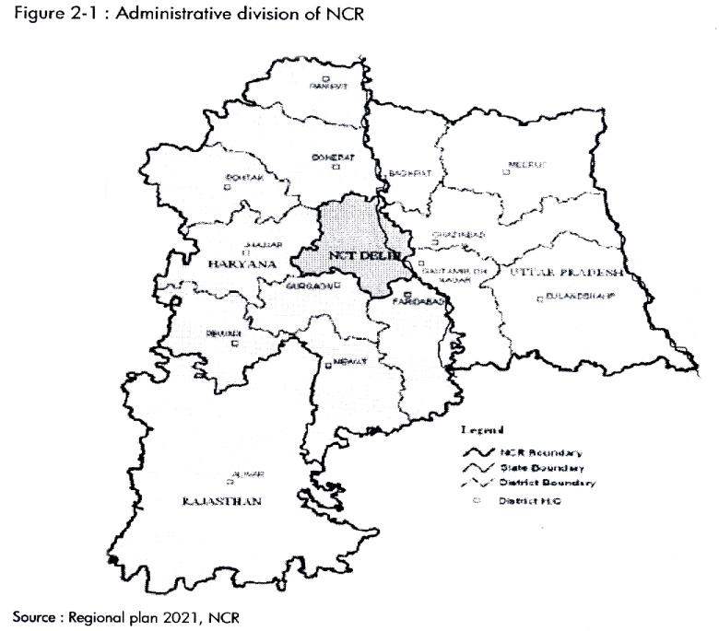
Source: Regional plan 2021, NCR
Topographically, the NCR has two major sub-units. The alluvial plains whose monotony is intercepted by isolated hillock or fairly continuous ridges of hard rock and sand dunes.
The major rivers NCR are the Ganga, the Yamuna, Hindon and Kali, which flows from north to south and a small part of Sahibi, which flows in the south western part. Most of the NCR is also predominantly irrigated through well developed canal network except Alwar and Gurgaon districts, which are irrigated by ground water.
Open wells, shallow tube wells, gravity wells and deep tube wells are abundant in the area covered by the alluvium. Their discharge vary anywhere from 18 to 25 cubic metres per hour for about 2 to 3 meters drawn down in the open wells to about 162 per cubic metres per hour for about 8-12 metres draw down in the deep tub wells.
As far as ground water quality is concerned, there are few fresh water pockets in the north east and south east corners of NCR, otherwise in these area the total dissolved solids (TDS) are more than desirable limits and other quality parameters as within the desirable range. The TDS (nitrate and fluoride) are more than desirable limits in the NCT Delhi area and most part of the north-west and south west part of NCR.
The NCR area lacks in vegetation cover (forest) and mineral resource on the whole. The major mineral deposits of the region are china clay, quartz silica sand and fire clay.
2.2.2 Policy zones and Land use zones
For the regulated and controlled development of the NCR there are four policy zones and four land use zones has been recommended as discussed below;
- Policy zones;
- NCT Delhi
- Central National Capital Region (CNCR): The notified controlled areas of the adjoining towns of Ghaziabad-Loni, Noida, Gurgoan-Manesar, Faridabad-Ballabhgarh, Bahadurgarh, and Sonepat-Kundli.
- Highway Corridor Zone: The controlled area comprising a minimum width of 500 meters, inclusive of green buffer, on either side of the right of way along the National Highway Nos. 1, 2, 8, 10, 24, 58 and 91 converging to Delhi.
- Rest of NCR: The area of the NCR outside the designated CNCR and Highway Corridor Zone, comprising both urban and rural areas.
The figure (2.1) below shows policy zones of NCR.
Figure 2-2: Policy zones of NC
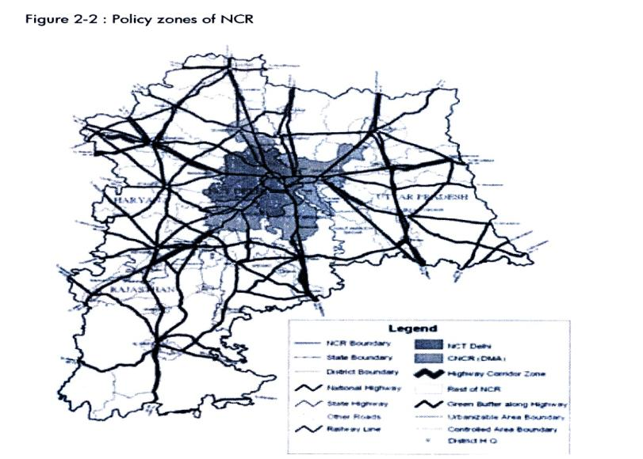
Source: Regional Plan 2021, NCR

B. Land use zones:
(i) Controlled / development / regulated zone
(ii) Highway corridor zone
(iii) Natural conservation zone
(iv) Agricultural (rural) zone outside controlled area / development / regulated zone
Figure 2-3: NCR Land Use Zones
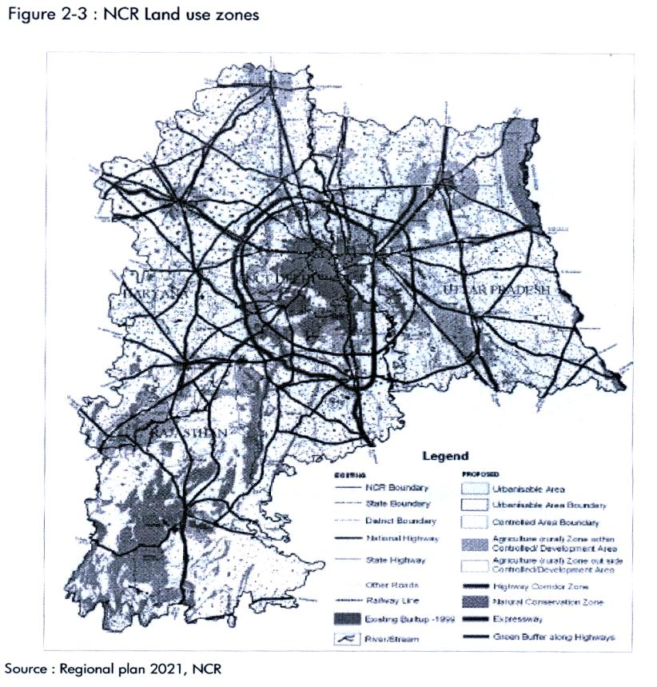
Source: Regional Plan 2021, NCR
- Controlled / Development / Regulated Zone: The controlled area zone demarcated in proposed landuse plan is under intense pressure of development. The activities within this zone will have to be effectively controlled and monitored. For this purpose while all a controlled areas declared by the respective State governments from time to time within the preview of their own acts will be deemed as controlled areas / regulated zone. Within controlled areas / regulated zones there will be three sub-zones, whose precise delineation will be undertaken by respective master plan for controlled development.

- Urbanisable Areas (including existing built up / urban areas)
- Agriculture (Rural) Zone within controlled / development regulated areas
- Green buffers

- Highway Corridor zone: In order to control the large scale urban development along the important highways in the region, outside the controlled / development / regulated zone, a regulatory zone is provided within which necessary planned development can be undertaken. It includes all major roads and highways within the Haryana sub region: such as;

NH-1: Delhi to Amritsar
NH-10: Delhi to Rohtak
NH-71: Rohtak to Jind
NH-8: Delhi to Gurgaon and beyond
NH-2: Delhi to Calcutta
Controlled area of 500 meters from the ROW (right of way) is mandatory. All major roads and state highways such as state highway 10, state highway 20, state highway 22, state highway 24, and state highway 25 have been in restriction of 500 meters of controlled zone. The actual boundaries of the highway corridor zone will be delineated based on the revenue village boundaries by the respective state governments in such regional plan.
- Natural area Conservation Zone : Major natural features identified as environmentally sensitive areas, are the extension of Aravalli ridge in Rajasthan. In NCR, these areas have been demarcated as Natural area conservation zone in the regional plan 2021. Similarly, ground water recharging areas such as water bodies, ox bow lakes, and paleo channels have also been identified. Therefore all the Aravallis within the Haryana state, in addition to the local agricultural zone have to be further detailed out in sub regional plan.
The extension of Aravallis ridge, sanctuaries and other ecologically sensitive areas needs to be conserved with utmost care and afforested with suitable species. The development in this area is to be in accordance with the Environment Act, 1986 from time to time. In view of the very low existing forest cover (4.02%), it is imperative to bring more areas under forest so as to maintain the ecological balance in this region. Accordingly, all wastelands identified in the existing landuse plan and proposed land use plan 2021, ROW of irrigation canals, drains, roads and railway lines are proposed to be brought under forest cover which is proposed to be 10% of the total area of the region.
The areas under water bodies and ground water rechargeable areas will be kept free from any encroachment / development to allow free flow of water, construction activities for human habitation or for other ancillary purpose thereto not be permitted. Suitable measures are to be taken to maintain the water bodies with the minimum flow or water level. In the flood prone areas / river banks, no construction or habitation activities are to be permitted. Flood protection plan be prepared by the concerned state government / agency.
Detailed conservation plan be prepared for the areas shown in Natural conservation zone in the Landuse Plan 2021 given at the end of discussion. The monuments / man made heritage sites and conservation areas be identified in the master plan / zonal plan of each town and detailed conservation.
- Agricultural zone outside controlled / development / regulated areas: Agricultural (Rural) area of NCR has to be regulated by village and block plans to be drawn under district planning process. At the regional level, agricultural zone be designed for primary sector production and as open areas comprising of farmlands, orchards and pastures etc.
The new employment opportunities in non agriculture sector and consequent concentration of population, the urban expansion would have to be largely made from the agricultural land and other non urban uses. In view of this, following policies have been proposed;
- Existing cultivated land be conserved for agricultural use as far as possible
- Efforts be made to increase the production through intensive cultivation by providing irrigation facilities and other necessary infrastructure
- Measures to be initiated for protection of prime agricultural land and ensure its needless conservation into non agricultural use
- Utilization of less and least valuable land for urban expansion / new urban centers / development purposes.
2.3 Haryana Sub-Region of NCR
2.3.1 Constituent area of Haryana Sub-Region
Haryana Sub-region is part of National Capital Region around Delhi. The constraints of space and high costs associated with development within NCT Delhi, are causing spill over of economic activities from Delhi which could be absorbed by neighbouring states like Haryana, Uttar Pradesh and Rajasthan, in case they are ready to receive them with appropriate physical and social infrastructure support, matching the investors’ perception.
The Haryana sub region comprises of the following nine districts, situated on the periphery of Delhi, forming the NCR Sub Region:
Table 2-2: Haryana Sub-Region profile
Districts | Area (Sq.Km.) | Population | Population density (person/Sq.Km.)
Panipat | 1268 | 967449 | 763
Sonipat | 2122 | 1279175 | 603
Rohtak | 1745 | 940128 | 539
Jhajjar | 1834 | 880072 | 480
Rewari | 1594 | 765351 | 480
Gurgaon | 1254 | 870539 | 694
Mewat | 1859 | 993617 | 534
Faridabad | 743 | 1365465 | 1838
Palwal | 1368 | 829121 | 606

Source: Census of India 2001

Figure 2-4: Haryana Sub-Region Political Map

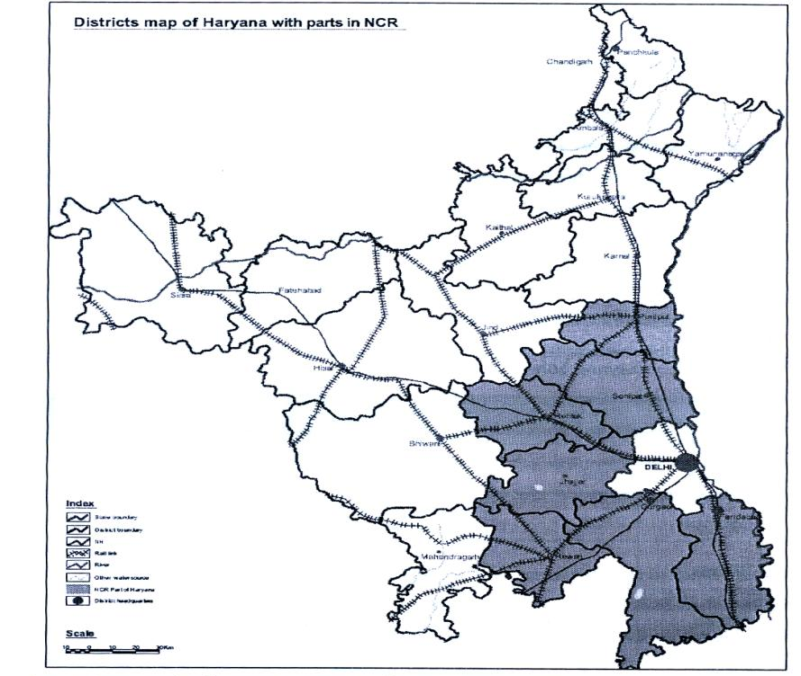
Source: Resource atlas of Haryana, Science & Tech. Dpt. Haryana, 2004
2.3.2 Physiography of the Haryana Sub-Region
Physiography of Haryana Sub-Region is almost plain made up of alluvium of Yamuna river with some pediments of Aravalli. All most all districts of sub-region is having same physiography except those area which are more dominated by Aravalli.
Panipat district is a part of alluvial plain of Yamuna river. It slopes from west to east and water of the area flows towards Yamuna. There are two major physiographic units in the area. The flood plain which is within one mile of the Yamuna river, has light soils and the water table is very near to the surface. This flood plain of the river Yamuna is suitable for rice and sugarcane cultivation. The other unit i.e. older alluvial plain spreading in the western part of the district is inclined towards the south and south-west area. This area is irrigated by tube wells and canals and is a prosperous agricultural area. The district has a perennial river Yamuna, which forms the eastern boundary of the district.
Sonepat district has almost a plain topography. Physiographically, it may roughly be divided into two units. The Khadar, which lies along the Yamuna in a narrow flood plain ranging from two miles in width, has medium to fine textured soils. The upland plain, which is spread in the west of the Khadar, is about 20 to 30 feet higher than the Khadar and is 735 feet above means sea level. It is covered with old alluvium.
Rohtak district is comprised of the vast Indo-Gangetic alluvial plains called older alluvial plain. This older alluvial plain is further divided into sand dunes, plan and depressions. The sediment derived in the old alluvial plain are mostly from the Himalayan rivers having a heterogeneous composition . This landform is formed predominantly by medium to fine textured soils. Since the soils are fertile with good irrigation facilities (canal and tube wells), these have been put into maximum use over a long time. This landform has been further divided into the following subunits:
- Dunal ridges / Plains: Dunal ridges, interdunal plains and plains with sandy Aeolian cover dominate the western and south-western part of Rohtak district.
- Plains: These occupy mainly the northern, north-eastern and north central parts of the study area, which are characterized by slight to moderate erosion, moderately distinct parceling and mixed tones due to variable moisture conditions. The soils ore mainly free from salt problems except in few small patches.
- Depressions: The post-Pleistocene age sediments which filed the depression areas are mostly derived from the Himalayan rivers from the north. The sediments itself is very deep and fine textured. The majority of the surface drainage is seasonal passing through linear depression areas. This unit occupies the north-eastern and north-central part of Rohtak distict.
Jhajjar district is comprised of the vast Indo-Gangetic alluvial plains. The main physiographical units of the district are as under:
- The upland plain spreads in the north-eastern part of the district. It slopes towards south. This plain is covered with old alluvium o high productivity. The sandy region is spread in the southern and south-western parts of the district. It comprises of permanent sand dunes, most of them now have been levelled. Sahibi is the only seasonal stream which enters the district from the south-eastern part and flows from the south.
- Alluvial Plains: The sediment derived in the alluvial plain are mostly from the Himalayan rivers having a heterogeneous composition. This landform is formed predominantly by medium to fine textured soils. Since the soils are fertile with good irrigation facilities (canal and tube-wells), these have been put into maximum use over a long time. The alluvial plain again has been subdivided as follows:

- Plains: These occupy mainly the northern, north-eastern and north central parts of the district, which are characterized by slight to moderate erosion, distinct parcelling and mixed tones due to variable moisture conditions.
- Depressions: The post-Pleistocene age sediments which filled the depression areas, are mostly derived from the Himalayan rivers from the north. The sediment itself is very deep and fine textured. The majority of the surface drainage is seasonal passing through linear depression areas. This unit occupies the north-eastern and north-central part of the district.
- Sand dunes / Plains: Dunal ridges, interdunal plains and plains with sandy Aeolian cover dominate the southern and south-western part of the district.
Rewari district can be divided into four terrain classes viz. Barren rocky / stony waste / sheet rocky, Sandy plain with sand dunes, Old flood plains and occasional hillocks and Undulating uplands with or without scrub. Generally physical condition of terrain and its evolution is the result of poly-cyclic activities and also affected by the change of climate. The Aravalli consist of organic and volcanic action and presently it is undergoing weathering and denudation. The hills traverse through western part of district roughly in south west to north east direction.
Gurgaon district comprises of hills onthe one hand and depression on the other, forming irregular and diverse nature of topography. Two ridges (i) the Ferozpur-Jhirka Delhi ridge forms the western boundary and (ii) the Delhi ridge forms the eastern boundary of the district. These hills are the northern continuation of the Aravallis. The north-western part of the district is covered with shifting sand dunes lying in the direction of westerly and south-westerly winds.
Mewat district has distinct topographic features with flat alluvial plains over most of the region, long and narrow pediments and local undulations caused by wind blown sands at eh foot hill zones and over much of the plains. The piedmont zone with eroded remnants and weathered rocks separate Rajasthan State and western part of the district from Punnhana and Ferozpur Jhirka on the east.
Faridabad and Palwal district has monotonous physiogrphy and has alluvium deposits. The alluvial plains have been divided into two units. Khadar that is low lying flood plain of newer alluvium and Banger, an upland plain made of older alluvial and is spread towards west. The general slope in the district is towards east. The levelled surface, fertile alluvial soil and facilities for irrigation make the district beast suited for intensive cultivation. The district enjoys with perennial river Yamuna, bordering it on the east. The river forms narrow but consistent flood plains. There are also few artificial lakes namely Suraj Kund, Badhkal, Peacock and Dhauj Lake etc.
    - Geology of Haryana Sub-Region
Geology is defined as the study of rocks and minerals of the earth with respect to their origin, composition and mode of occurrence. The Haryana State comprises a good assemblage of rocks belonging to age from Pre-cambrian to Quaternary. The state can be divided in three different geological domains:
- Pre-Cambrian rocks of Aravalli Mountains
- Tertiary rocks of Himalayas and
- Quaternary deposits of Indo-Gangetic Plains
Out of above mentioned three geological division Haryana sub-region is dominated by Quaternary deposits of Indo-Gangatic plains and Pre-Cambrian rocks of Aravalli mountains.
Panipat: The district has not much geological diversity. It is entirely covered by old and new alluvium deposits of quaternary to recent age, which consists of clay and sand. Consolidated and un-consolidated sands are also found at places in the district.
Sonipat: The districts is almost entirely covered by alluvial deposited of clay, loam, silt and sand brought down by river Yamuna. High grade silica sand left behind by the change in course of the Yamuna river is found in the district.
Rohtak : The geological structure of the district consists of alluvium (recent), loam (Bhangar and Nadrak), coarse loam (daher and chaeknote). Infect, the district is a part of indo Gangetic alluvial plain ranging from Pleistocene to recent age. Aeolian deposits of sub recent age cap the plains. The sediments comprise of clay, sand and kankar mixed in different proportions. No exposure of hard rocks forming the basement are seen in the area which one as deep as three hundred metres. Geological succession of the area is as under:-
Age | System | Formation
Pleistocene | Recent to sub recent | Alluvial Aeolian sand

Jhajjar: The area forms a part of in Dugan ethic plain ranging from Pleistocene to recent in age Aeolian deposits of Sub-recent age cap the plains. The sediments comprise of clay, sand and Kankar mixed in different proportions. No exposure of hard rock farming the basement is seen in the area.
Rewari : The purona rocks in Rewari district belongs to Ajabgarh series of Delhi system. The hills have been denuded since ages and hence are with a height ranging from 300m to 425m above mean sea level. The hills are mostly steep, bare and rocky. The hillocks and discontinuous ranges are locally called khols, which are known for mineral bearing rocks. Sandy plains are notable landscape feature in Rewari district which are present in the east of Aravalli hills and are having a scattered pattern of stabilized to partially stabilized sand dunes due to sand deposition from south westerly winds coming from adjacent Rajasthan desert. The previously existing old flood plains have been superimposed by Aeolian plains and sand dunes. These plains are impregnated with sand dunes 1 to 3 meter high above ground and which are mostly stabilized.
Gurgaon : The large part of the district is occupied (i) by scattered isolated strike ridges of old rocks, the relicts of a former Aravalli mountain chain of Pre-Cambrian and (ii) alluvium, sand of recent to sub-recent origin.
Mewat : The large part of the district is occupied (i) by scattered isolated strike ridges of old rocks, the relicts of a former Aravalli mountain chain of Pre-Cambrian and (ii) alluvium, sand of recent to sub-recent origin.
Faridabad and Palwal : The major part of the district is occupied by vase alluvial plains of recent to sub-recent age, which include older (Bangar) and newer (Khadar) alluvial and kankar. The kankar occurs mainly in the northern part and is poor in calcareous matter.
2.3.4 Natural resources
2.3.4.i Water bodies
Haryana State is a part of two major river basins namely, the Ganga and the Indus. The Ganga river basin occupies the eastern part covering an area of about 30000 square kilometres whereas the western parts fall under the Indus river basin.
Yamuna is the only perennial river in the Sub-Region, which originates in Tehri district of Uttaranchal. It forms the boundary between Haryana and Uttar Pradesh. The Yamuna sub-basin covers parts of the districts of Panipat, Sonepat, Rohtak, Gurgaon and Faridabad.
The river basin area between Yamuna and Ghaggar drainage basin, which are flat and have no drainage outfall in either of the rivers, forms the Inland drainage basin. The inland drainage basin covers the districts of Rewari, Rohtak and parts of Gurgaon. The Aravalli hill ranges occupying the southern margins of Haryana Sub-Region bring a number of small rainy streams from Rajasthan side into Gurgaon, Jhajjar and Rewari. Among these streams the Sahibi, Krishnawati, and Dohan are the major ones. Artificial drains have been constructed in the inland drainage basin to drain the excessive rainwater to the main rivers. In the Sub-Region a number of small ponds or jhil exist of which Najafgarh jhil, Jahajgarh Jhil, Barkhal Jhil, Surajkund Jhil and Sohna Jhil are the most important.
Canals are the most popular and important source of irrigation in Haryana Sub-Region due to easy supply and regular flow of water to the agriculture fields. In the Inland drainage basin the drains excavated are made to outflow in canals through lift pumps. The canals network is dense in most of the district except in the districts of Rewari and Gurgaon where there is a general absence of canals. There are four irrigation systems in the State namely Western Yamuna Canal, Bhakra Canal, Agra Canal and Ghaggar Canal. The Bhakra and Western Yamuna Canal system are interlinked and it is difficult separate their command areas. All the districts except Gurgaon and Faridabad fall under their commands. The Bhakra Irrigation System (which receives water from Gobind Sagar Reservoir) and the Western Yamuna Canal system irrigate the major parts of the State. Western Yamuna Canal depends of the water availability in Yamuna river because no dam has been made on the river in the recharge area to tap the water for canal feeding. To cater to the needs of each other both the canal systems have been jointed. Lift irrigation scheme has been developed for the purpose of irrigation with the help of these canals. The districts of Faridabad and Gurgaon fall under Agra canal commands. The topography of the State is such that district of Mahendragarh, Rewari, Bhiwani and part of Jhajjar and Rohtak cannot be brought under gravity canal commands.
2.3.4.ii Minerals
Minerals play an important role in the development of the State’s economy. The various rocks and minerals found in the State according to definitions contained in the Mines & Minerals Act, 1957 under section 3(E), are classified as ‘minor minerals’ and remaining as minerals commonly known as ‘major minerals’. Minor minerals include building stones, gravel, ordinary clay, ordinary sand, boulder, chalcedony pebble, kankar and limestone (used for lime burning), murrum, brick earth, fuller’s earth, bentonite, road metal, rehmatti and shale (used for building materials), salt patre and granite. Minor minerals are the major sources of income because maximum amount of revenue is derived from the auctioning of these minerals. Almost all the industrial rocks and minerals are grouped under major minerals.
Haryana sub-region has very little mineral wealth. The region is having mainly brick earth, saltpetre and quartzite. Excellent quality slate is found in the Rewari and Gurgaon districts. Badar sand also called bazri is found in huge quantities in the hilly terrain of Aravallis in Faridabad and Gurgaon district. Siliceous kankar and lime kankar and lime kankar occur in huge quantities in parts of Jhajjar district. Brick earth / ordinary clay suitable for manufacturing of bricks is available in plenty in almost every part of the Salt Petre occurs as thin white incrustations on the surface. Its major occurrences are in Rohtak, Practically inexhaustible deposits of quartzite are found in the state in the Aravalli ranges in the districts of Faridabad, Gurgaon, Rewari Low-grade haematitie and jasperiod haematite occur in Ferozpur-Jhirka area of Gurgaon district.
A number of major minerals, though in minor quantities, are also found in the state. These include aresenopyrite (Alwar quartzites in Grugaon district) china clay (in the fieldspathic pegmatite veins in Alwar quartzites in Faridabad and Gurgaon district), feldspars (in pegmatites intruding quartzites in Gurgaon district), garnet (in garnetiferous mica schist associated with Alwar quartzites in Gurgaon district), graphite (in graphite mica schist occurring in Gurgaon district), foundary sand (in abandoned course of Yamuna river in Sonepat district), quartz (as intrusive veins with pegmatites in Gurgaon and Faridabad district).
Figure 2-5: Mineral map of Haryana Sub-Region
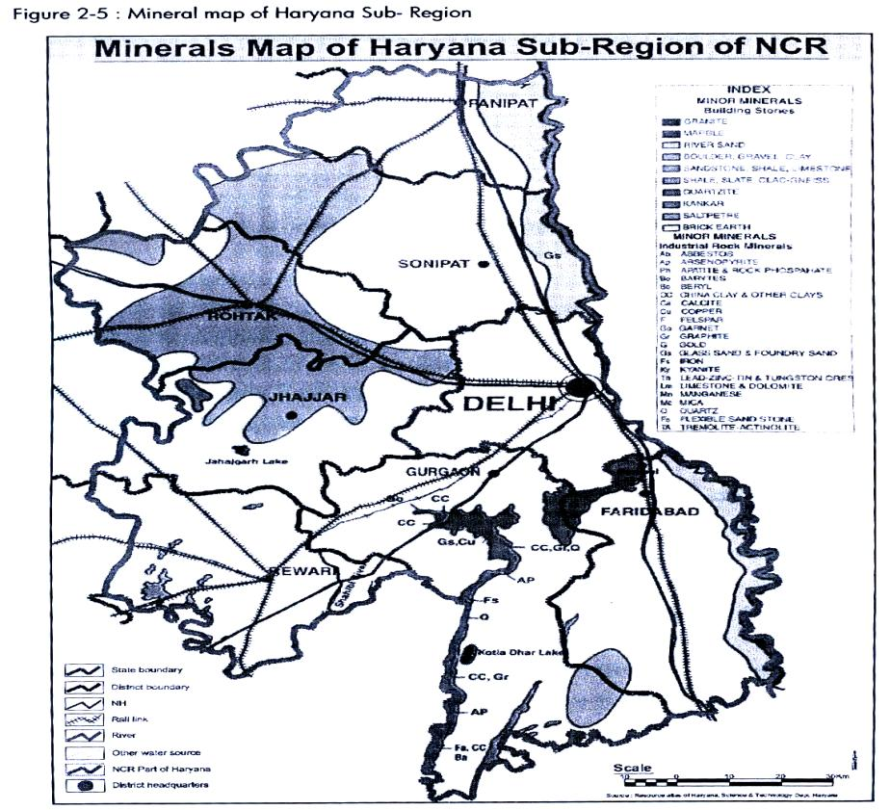
Source: Resource atlas of Haryana, Science & Tech. Dpt.,Haryana, 2004
2.3.4.iii Soil of Haryana Sub-Region
Soil constitutes the most precious natural resource of the State. A variety of soils are found in Haryana due to the marked variation in the physiographic and climatic conditions. Soil of the Haryana Sub-Region have been classified and described under the following major soil types:
* Typic Ustochrepts : Soil of old alluvial plains
* Typic Ustipsamments : Soil of Aravalli plains
* Typic Ustifluvents : Soil of recent alluvial plains and flood plains
* Typic Torripsamments : Soil of Aeofluvial plains
* Rock Outcrops : Aravalli rocky hills
Now district wise details of soil and their characteristics are described below:
Panipat : The soils are well drained, Sandy loam to clay loam/silty clay loam in plains and loam to clay loam / silty / loose clay loam in relic channels/depressions/basins.
Sonipat : The districts comprises of recent flood plains, young meander plains, old meander plains and old alluvial plains. Recent flood plains occur a few kms. Along the Yamuna river and clearly show fluvial features. The young meander plains show meandering features left by river Yamuna like Palaeochannels, natural levees, point bar complexes, meander cut off and sand bars. The soils are loamy sand to sandy loam on the surface and sandy loam to clay loam in the sub surface. Old meander plains are almost flat with loamy sand to silty clay loam soils. Oldest among all the land forms are old alluvial plains, which cover the major area in the district. These soils are sand to loamy sand/sandy loam (surface) to silt loam/silty clay loam (sub-surface).
Figure 2-6: Soil map of Haryana Sub-Region of NCR
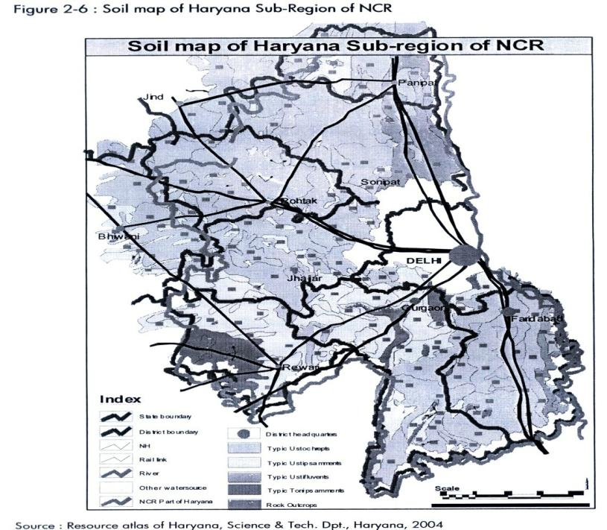
Source: Resource atlas of Haryana, Science & Tech. Dpt., Haryana, 2004
Rohtak : The district mainly comprises of old alluvial plains. The soils are loamy sand to sandy loam on the surface and sandy loam to clay loam in the sub surface. Old meander plains are almost flat with loamy sand to silty clay loam soils. Oldest among all the land forms are old alluvial plains, which cover the major area in the district. These soils are sand to loamy sand / sandy loam (surface) to silt loam / silty clay loam (sub-surface).
Jhajjar: The districts mainly comprises of old alluvial plains and some part of the district comprised of soil of Aravalli plains.
Rewari : The soils of the district fall under Entisols and Inceptisols orders. The surface soil texture varies from sand to fine loamy sand. These are excessively drained with slight to moderate soil erosion having high percolation rate. In fluvial low lands the soils are heavier in texture that varies from sandy loam to loam. These soils are well to moderately well drained with slight erosion.
Gurgaon : The district comprises of sand dunes, sandy plains, alluvial plains, salt affecter areas, low lands, lakes, hills and pediments. The soil varies from sand to loamy sand in sand dunes and sandy plain areas, sandy loan to clay loan / silty clay loan is alluvial plains, calcareous, loamy sand to loam in salt affected plains, silty load to loam in low lands and calcareous, loamy sand to loam in hills.
Mewat : The soils of the area are generally sandy loam to loam. In parts of the low-lying areas, they are clayey and saline. The soils are light and derived from the older and new alluvial layers; the older alluvial is dark-coloured and is generally rich in concretions and nodules of impure calcium carbonate known as “Kankar”. The new alluvium is light coloured and poor in calcareous matter. The soils are generally shallow and low in organic matter.
Faridabad : The district comprises of recent Yamuna flood plains, low lying plains, depressions, sand dunes and hills. The texture of the soil is sand to loamy sand in recent Yamuna flood plains, sandy loam in plains, sandy load to clay loam in alluvial plains, sandy loam to loam (surface), clay loam/silty clay (sub-surface) in low lying plains/depressions.
Soil types with their agricultural productivity are:
1. Soils of Aravalli Plains
Location: In vicinity of the aravalli hills and in the parts of Gurgaon, Mewat, Faridabad and Rewari in the sub region.
Characteristics : They are frequently distributed by Aeolian activity. The soils of this unit are described under two moisture regimes:
Soil Type: the dominated soils of the aridic zone occur on the sand dunes of the shifting nature. They are sandy, single grain and are alkaline. They are classified as typic torripsamments. The associated sub dominant soils are coarse-loamy typic camborethids. They belong to interdunal areas and are deep, well drained, neutral to slightly alkaline, poor in organic carbon content and fertility.
Cultivation: They are cultivated to Bajara, Gram, Oilseed and Pulses.
Constraints:
* Moderate to severe wind and water erosion
* Poor soil structure
* Poor fertility (Low O.C., low CEC)
* Low water holding capacity
2. Soils of old Alluvial Plains
Location: Soils of this region are spread over parts of Panipat, Sonipat, Rohtak, Jhajjar, Faridabad and Palwal districts.
Characteristics : The dominant and sub dominant soils have been classified as typic ustocherepts and in some areas as udic ustochrepts.
Soil Type : The sub dominated soils are deep, well drained, with or without salinity and / or sodicity problem. Other sub dominated soils are imperfectly drained, fine loamy, calcareous, sodic with high pH and exchangeable sodium percentage. They are classified as nitric ustochrepts and poorly drained fine loamy fluventic ustochrepts.
Cultivation: These soils respond very well to the application of fertilizers and irrigation. Wheat, paddy and sugarcane are the major crops. Excessive use of irrigation water especially of poor quality has created many problems.
Constraints:
- Salinity
- Sodicity
- Poor drainage
- High ground water table
3. Soils of old Alluvial Plains with sand dunes
Location: Soils of this unit are spread over parts of Rohtak, Jhajjar, Gurgaon and Mewat districts. Aeolian sands are deposited by the south western winds from the Rajasthan. Sand dunes of many places have been reclaimed and stabilized.
Characteristics: soils of this unit are described under two moisture regime: Ustic and Aridic. Majority of the soils ustic moisture regime ustic moisture regimeoccur in Rohtak and Jhajjar districts.
Soil Type : Dominated soils of Ustic moisture regime are very deep, somewhat excessive drained, severely to moderately eroded and sandy in texture, classified as typic Ustipsamments.
Cultivation: With adequate soil and water conservation measures they have very good yield potentials for rainfed crops. Adequate application of FYM and fertilizers insplit doses will enhance the productivity of these soils.
Constraints:
- Low Fertility
- Salinity
- Moderate to severe erosine
- Poor retention of moisture in the root zone
Figure 2-7: Soil Fertility map of Haryana Sub-Region
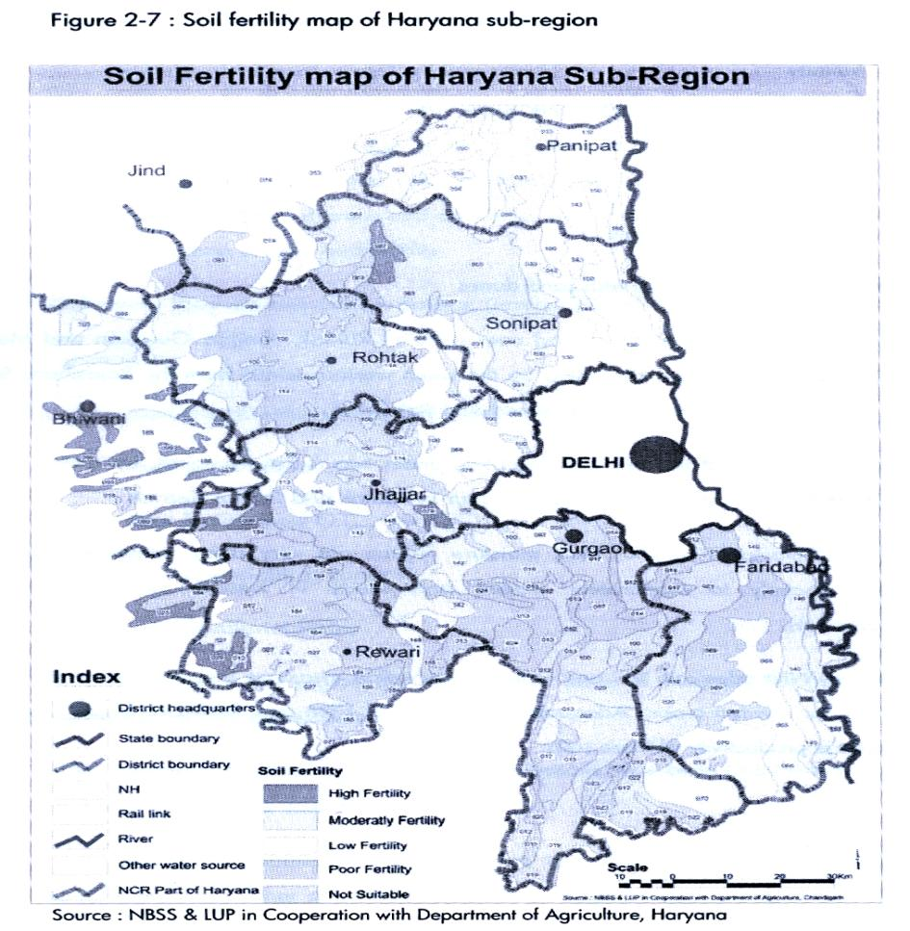
Source: NBSS & LUP in Cooperation with Department of Agriculture, Haryana
4. Soils of recent Alluvial Plains
Location: Soils of this unit are developed from the alluvial deposits along the bank of the Yamuna and its tributaries in parts of Panipat, Sonipat, Faridabad and some part of Rewari. They are occasionally subject to moderate flooding during heavy rains.
Characteristics : The dominating soil in recent flood plains of the Yamuna is coarse-loamy and sandy. They are classified as coarse-loamy, calcareous as well as non-calcareous typic Ustifluvents and coarse-loamy and fine-loamy, fluventic Ustochrepts.
Soil Type: Sub-soil water of good quality facilities intensive farming. Conservation measures and application of recommended doses of FYM and fertilizers are some of the suggestive measures.
Cultivation: They are cultivated for wheat and paddy in the low lying areas while bajra and gram are cultivated on levees.
Constraints:
- Moderate seasonal flooding
- Shallow ground water table
- Slight to moderate erosion
- Low to medium fertility
5. Soils of Fluvio-aeolian Plains
Location: Soils of this unit are located in Rewari and western part of Rohtak District. They are occasionally subject to moderate flooding during heavy rains.
Characteristics: The soil of this unit are of Aeolian nature modified by fluvial activity of river Sahibi. The annual rainfall ranges between 300-500 mm. The soil of this unit under two moisture regimes:
Soil Type: Domestic soils are very deep, excessive drained, slightly alkaline, sandy and calcareous, occurring on gentle sloping plains. These soils are the Ustic moisture regime as typic Torripsamments. Subdominant soils in Ustic moisture regime are well drained, coarse-loamy, calcareous, typic Ustifluvents and fine loamy typic Ustochrepts.
Constraints:
* Poor soil moisture
* Poor Fertility
* Moderate wind erosion
* Low water holding capacity
2.3.4.iv Ground water
Ground water is an important resource for meeting the water requirements for irrigation, domestic and industrial uses. Ground water is annually replenishable resource but its availability is non-uniform in space and time. In Haryana sub-region ground water occurs in alluvium as well as in hard rocks. In alluvium, sand, silt, kankar and gravel beds constitute potential water bearing zones whereas in hard rocks weathered /fracture quartzites and cavernous limestones constitute potential aquifers. Ground water at shallow depths occurs under unconfined conditions, whereas at deeper levels confined/conditions prevail.
a) Ground water status
In the Sub-Region the ground water is extensively used for irrigation and domestic purpose. Due to tremendous increase in the requirement of ground water for agriculture, industries and by newly developed urban areas, the water levels have shown a continuous declining trend in a number of districts. On the contrary the excessive use of canal water for agricultural purpose coupled with unfavourable geological conditions, lack of natural surface drainage and poor quality of ground water, the less utilized ground water have risen towards the ground causing water logging conditions in some districts. The quality of ground water in Haryana Sub-Region has changed significantly during past decades due to industrialization, urbanization and agricultural growth.
If we see the ground water depth in various district of the Sub-region since 1974 to 2009, we find that there is drastic fall in ground water level mainly in the district of Gurgaon, Rewari and Panipat. In the Sub-Region since 1974 to 1995 there was minor decrease in ground water level and between 1995 to 1997 water level has increased but after that till 2009 there is continuous decline in the ground water level. So, mainly since 1997 the water depth of the Sub-Region has increased tremendously. It can be easily understood through following, figure 2.8 and table 2.3.
Figure 2-8: District wise Ground water depth
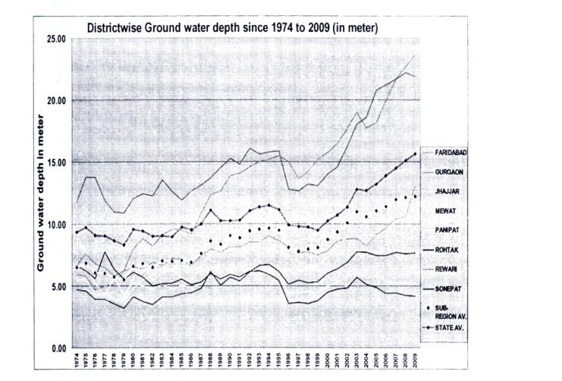
Table 2-3: Ground water depth since 1974 to 2009
Year | Month | 1974 | 1975 | 1976 | 1977 | 1978 | 1979 | 1980 | 1981 | 1982 | 1983 | 1984 | 1985 | 1986 | 1987 | 1988 | 1989 | 1990 | 1991
FARIDABAD | JUNE | 5.94 | 5.82 | 4.7 | 4.99 | 5.12 | 6.2 | 6.53 | 6.37 | 6.87 | 6.63 | 7.24 | 7.11 | 6.62 | 7.45 | 7.94 | 7.71 | 8.16 | 8.14
 | OCT. | 4.77 | 3.93 | 3.71 | 4.19 | 3.92 | 4.97 | 5.71 | 5.47 | 6.86 | 6.11 | 6.25 | 5.67 | 6.58 | 7.63 | 6.14 | 7.46 | 7.82 | 7.66
GURGAON | JUNE | 6.64 | 7.62 | 6.8 | 6.51 | 5.82 | 6.24 | 8.01 | 8.8 | 8.21 | 9.14 | 9.56 | 9.51 | 9.18 | 10.85 | 12.37 | 12.66 | 13.05 | 14.0
 | OCT. | 6.33 | 5.58 | 5.5 | 4.52 | 4.59 | 6.18 | 7.81 | 8.04 | 8.31 | 8.05 | 7.74 | 8.28 | 9.73 | 11.05 | 11.14 | 12.9 | 1305 | 14.29
JHAJJAR | JUNE | 6.32 | 6.36 | 5.27 | 4.16 | 5.67 | 4.24 | 5.23 | 4.98 | 4.73 | 5.12 | 4.69 | 5.04 | 4.82 | 5.16 | 5.74 | 5.66 | 5.99 | 5.77
 | OCT. | 5.77 | 4.5 | 3.98 | 2.88 | 3.4 | 4.86 | 4.81 | 4.47 | 4.69 | 35.3 | 4.05 | 3.56 | 4.54 | 5.3 | 4.73 | 5.64 | 5.11 | 5.24
MEWAT | JUNE | 5.5 | 5.54 | 4.28 | 4.41 | 4.53 | 3.97 | 5.7 | 6.99 | 5.41 | 6.12 | 6.26 | 5.66 | 5.28 | 6.57 | 7.55 | 8.02 | 8.79 | 8.67
 | OCT. | 4.14 | 3.49 | 3.17 | 2.64 | 2.84 | 3.96 | 5.59 | 5.13 | 4.95 | 4.37 | 4.45 | 4.0 | 5.53 | 6.82 | 6.62 | 8.1 | 7.37 | 7.68
PANIPAT | JUNE | 4.56 | 4.78 | 4.26 | 4.44 | 3.93 | 3.79 | 4.78 | 5.49 | 5.84 | 6.39 | 6.19 | 7.24 | 7.13 | 7.68 | 9.49 | 7.75 | 8.6 | 8.41
 | OCT. | 4.18 | 3.51 | 3.76 | 3.22 | 2.5 | 3.92 | 3.93 | 5.33 | 5.51 | 5.25 | 4.99 | 5.92 | 6.58 | 8.04 | 6.87 | 7.87 | 7.78 | 8.75
ROHTAK | JUNE | 6.64 | 6.24 | 5.61 | 7.74 | 6.36 | 5.54 | 6.09 | 5.71 | 5.0 | 5.18 | 5.19 | 5.56 | 5.06 | 5.29 | 5.98 | 5.53 | 5.94 | 5.72
 | OCT. | 5.83 | 4.6 | 4.66 | 4.98 | 5.41 | 6.04 | 5.08 | 4.92 | 4.75 | 4.03 | 4.23 | 4.4 | 4.57 | 5.7 | 4.94 | 5.6 | 5.46 | 5.26
REWARI | JUNE | 11.75 | 13.75 | 13.75 | 11.91 | 10.96 | 10.9 | 12.05 | 12.42 | 12.27 | 13.54 | 12.6 | 11.92 | 12.4 | 13.11 | 13.73 | 14.56 | 15.27 | 14.82
 | OCT. | 11.61 | 13.37 | 12.43 | 10.65 | 10.11 | 10.9 | 11.41 | 11.2 | 12.62 | 12.17 | 12.11 | 11.76 | 12.8 | 13.34 | 13.32 | 14.75 | 14.34 | 15.24
SONEPAT | JUNE | 4.68 | 4.6 | 3.9 | 3.92 | 3.56 | 3.19 | 4.11 | 3.76 | 3.49 | 4.07 | 4.09 | 4.34 | 4.43 | 4.77 | 6.15 | 5.05 | 5.69 | 5.36
 | OCT. | 3.89 | 3.4 | 2.85 | 2.53 | 2.52 | 3.55 | 2.79 | 3.24 | 3.04 | 2.5 | 3.15 | 3.65 | 4.19 | 5.28 | 3.93 | 5.21 | 4.73 | 5.07
SUB-REGION  AVERAGE | JUNE | 6.50 | 6.83 | 6.07 | 6.01 | 5.74 | 5.50 | 6.56 | 6.81 | 6.47 | 7.02 | 6.97 | 7.04 | 6.89 | 7.61 | 8.61 | 8.36 | 9.04 | 8.87
 | OCT. | 5.81 | 5.29 | 5.00 | 4.45 | 4.41 | 5.54 | 5.89 | 5.97 | 6.34 | 5.75 | 5.87 | 5.90 | 6.81 | 7.89 | 7.21 | 8.44 | 8.20 | 8.64
STATE AVERAGE | JUNE | 9.35 | 9.73 | 9.08 | 9.05 | 8.64 | 8.3 | 9.55 | 9.44 | 8.98 | 9.02 | 8.94 | 9.73 | 9.52 | 9.99 | 11.12 | 10.26 | 10.26 | 10.27
 | OCT. | 8.93 | 8.33 | 8.09 | 7.86 | 7.31 | 8.25 | 8.8 | 8.87 | 8.78 | 8.45 | 8.24 | 8.74 | 9.18 | 10.37 | 9.23 | 10.07 | 9.7 | 10.29

Year | Month | 1192 | 1993 | 1994 | 1995 | 1996 | 1997 | 1998 | 1999 | 2000 | 2001 | 2002 | 2003 | 2004 | 2005 | 2006 | 2007 | 2008 | 2009991
FARIDABAD | JUNE | 8.52 | 8.53 | 9.4 | 8.62 | 8.12 | 7.68 | 7.73 | 7.47 | 7.83 | 8.59 | 8.77 | 8.84 | 8.2 | 9.12 | 9.65 | 10.41 | 10.61 | 13.1
 | OCT. | 6.99 | 7.04 | 7.98 | 6.56 | 6.89 | 6.39 | 6.07 | 6.78 | 7.13 | 7.94 | 8.36 | 6.41 | 7.65 | 8.32 | 8.71 | 9.88 | 9.57
GURGAON | JUNE | 14.59 | 15.01 | 15.21 | 15.49 | 15.02 | 13.62 | 14.25 | 15.22 | 15.74 | 16.47 | 17.68 | 19.02 | 17.71 | 18.16 | 19.99 | 21.66 | 22.62 | 23.61
 | OCT. | 14.43 | 13.9 | 14.3 | 13.96 | 13.8 | 13.07 | 13.82 | 15.0 | 15.57 | 16.48 | 17.77 | 17.02 | 17.41 | 17.97 | 19.54 | 21.76 | 22.67
JHAJJAR | JUNE | 5.95 | 6.04 | 6.01 | 5.85 | 4.34 | 4.44 | 4.51 | 4.49 | 4.97 | 5.29 | 5.79 | 6.05 | 5.64 | 5.83 | 5.46 | 5.24 | 5.27 | 5.2
 | OCT. | 5.28 | 5.09 | 4.93 | 3.57 | 3.3 | 3.94 | 3.83 | 4.38 | 4.49 | 5.06 | 5.51 | 4.96 | 5.19 | 4.53 | 5.11 | 4.86 | 4.35
MEWAT | JUNE | 8.69 | 8.62 | 8.59 | 8.5 | 7.39 | 6.15 | 6.5 | 6.67 | 7.34 | 8.19 | 8.99 | 9.63 | 9.12 | 9.05 | 9.45 | 10.25 | 10.31 | 11.23
 | OCT. | 7.7 | 7.23 | 7.38 | 6.1 | 5.08 | 5.43 | 5.42 | 6.09 | 7.1 | 7.86 | 8.73 | 7.76 | 8.08 | 8.21 | 9.69 | 9.44 | 9.57
PANIPAT | JUNE | 9.13 | 9.65 | 9.83 | 9.88 | 8.45 | 8.71 | 8.78 | 8.53 | 9.58 | 10.41 | 11.27 | 12.63 | 12.68 | 13.1 | 13.63 | 14.24 | 14.45 | 14.09
 | OCT. | 9.31 | 9.18 | 8.44 | 7.44 | 7.21 | 7.78 | 7.01 | 8.89 | 9.39 | 10.32 | 11.68 | 12.19 | 11.98 | 12.67 | 14.23 | 14.97 | 14.34
PALWAL | JUNE |  |  |  |  |  |  |  |  |  |  |  |  |  |  |  |  |  | 8.83
 | OCT.
ROHTAK | JUNE | 6.17 | 6.21 | 5.94 | 5.42 | 3.55 | 3.64 | 3.59 | 3.8 | 4.49 | 4.74 | 4.84 | 5.67 | 5.12 | 4.88 | 4.41 | 4.45 | 4.2 | 4.19
 | OCT. | 5.5 | 4.9 | 4.94 | 2.46 | 2.43 | 3.08 | 2.64 | 3.7 | 3.83 | 4.39 | 4.86 | 4.18 | 4.38 | 3.46 | 3.99 | 3.91 | 3.15
REWARI | JUNE | 16.09 | 15.61 | 15.81 | 15.87 | 12.76 | 12.67 | 13.23 | 13.07 | 14.03 | 14.59 | 16.28 | 18.01 | 18.61 | 20.8 | 21.2 | 21.7 | 22.21 | 21.91
 | OCT. | 15.2 | 14.81 | 15.05 | 13.42 | 11.56 | 11.69 | 11.99 | 13.11 | 14.29 | 14.14 | 16.47 | 16.5 | 19.92 | 19.98 | 21.03 | 21.66 | 20.73
SONEPAT | JUNE | 6.13 | 6.64 | 6.73 | 6.14 | 5.14 | 5.46 | 5.24 | 5.33 | 6.04 | 6.36 | 6.87 | 7.76 | 7.7 | 7.43 | 7.44 | 7.7 | 7.56 | 7.68
 | OCT. | 5.58 | 5.16 | 5.0 | 3.95 | 3.97 | 4.7 | 4.35 | 5.46 | 5.72 | 6.21 | 6.58 | 7.06 | 6.89 | 6.56 | 7.06 | 6.99 | 7.0
SUB-REGION AV. | JUNE | 9.41 | 9.54 | 9.64 | 9.47 | 8.09 | 7.79 | 7.97 | 8.07 | 8.75 | 9.33 | 10.06 | 10.95 | 10.6 | 11.05 | 11.4 | 11.96 | 12.15 | 12.2
 | OCT. | 8.75 | 8.41 | 8.50 | 7.18 | 6.78 | 7.01 | 6.89 | 7.92 | 8.44 | 9.05 | 9.99 | 9.51 | 10.19 | 10.21 | 11.17 | 11.68 | 11.42
STATE AV.S | JUNE | 11.04 | 11.34 | 11.48 | 11.15 | 9.91 | 9.75 | 9.73 | 9.46 | 10.22 | 10.71 | 11.35 | 12.76 | 12.7 | 13.23 | 13.9 | 14.48 | 15.1 | 15.66
 | OCT. | 10.45 | 10.41 | 10.3 | 9.03 | 8.59 | 8.87 | 8.31 | 9.38 | 10.01 | 10.43 | 11.75 | 11.67 | 12.46 | 12.54 | 13.71 | 14.46 | 14.71
Source: Haryana Hydrological cell under Agriculture department

In the Sub-Region, only Rohtak and Jhajjar has shown improvement in the ground water status since 1974. In Rohtak and Jhajjar district ground water table in 1974 was at the depth of 6.64 meter and 6.34 meter respectively where as it has improved to 4.19 meter and 5.2 meter respectively in 2009. There are three districts namely Gurgaon, Rewari and Panipat which has lower ground water table than the Sub-Region average and shown drastic decline in ground water table depth. In 1974, Gurgaon, Rewari and Panipat had ground water table at the depth of 6.64 m, 11.75 m and 4.56m respectively and it has gone down to 23.61m, 21.91m and 14.09m respectively in 2009. Faridabad is also showing great decline in water table since 2003. In the Sub-Region Gurgaon and Rewari is worst in terms of availability of ground water. In the above table districts marked by red colour are showing drastic fall of ground water table, yellow colored districts are not in a critical stage but on the verge of decline in terms of ground water and those which are marked by green colour are having good condition or improvement in ground water depth.
b) Ground water quality
Industrial effluents, sewage waster, fertilizers, pesticides and insecticides cause a number of pollutants to enter into surface and ground water, thereby deteriorating water resources of the region. The Sub-Region has been divided into three quality zones based on the electrical conductivity (EC) values of ground water as: fresh water with EC value <2000 micro mhos/cm, marginal water with EC value 2000-6000 micro mhos/cm and saline water with EC value of more than 6000 micro mhos/cm and six combination zones based on the occurrence of ground water quality zone with respect to depth.
On the basis of above criteria if we see the ground water quality of the sub region then we find that these zones are distributed in patches in all over the region.
Fresh ground water:
Fresh ground water occurrences are more in the shallow aquifers’ as compared to deep aquifers whereas water salinity becomes prominent with the increase in depth of water bearing zones. Fresh water zones are found in the south-eastern parts of Rewari district. In these districts the presence of Aravalli hills, which acts as a ground water recharge zone and absence of canal irrigation has rendered the ground water quality as fresh.
Marginal Ground Water:
Marginal ground water is generally located around the zones of fresh water. Major zones of marginal ground water are found in majority of areas of Rewari district, western part of Gurgaon and central parts of Faridabad districts.
Saline Ground Water:
Saline ground water occurs mainly in the northern parts of Jhajjar district and at number of places in Rohtak. Some areas occur in central parts of Gurgaon and Faridabad districts. This is aggravated due extensive canal network adding surface water to saline ground water and non-exploitation of ground water due to its saline quality. This has resulted in rise in water table and water logging. The salinity in the south-western and south-eastern parts of the Faridabad and Gurgaon district respectively can be explained in terms of desiccation of water in these flat and semi arid plains coupled with under exploitation of ground water.
The shallow marginal-deep fresh zones are found associated with fresh water zones as seen in the districts of Rewari and Gurgaon, Deep Saline Zones are generally associated with saline zone. These zones cover majority of areas is Sonipat, Jhajjar district and south-western and south-eastern parts of Faridabad and Gurgaon districts.
Mapping of Ground Water zone as per their suitability for domestic, irrigation and industrial uses is highly desirable for proper management of ground water resources and to safeguard human being from consumption of poor quality ground water. To check further deterioration of quality of ground water in the State regular monitoring of their chemical quality is necessary.
Figure 2-9: Ground water quality of Haryana Sub-Region
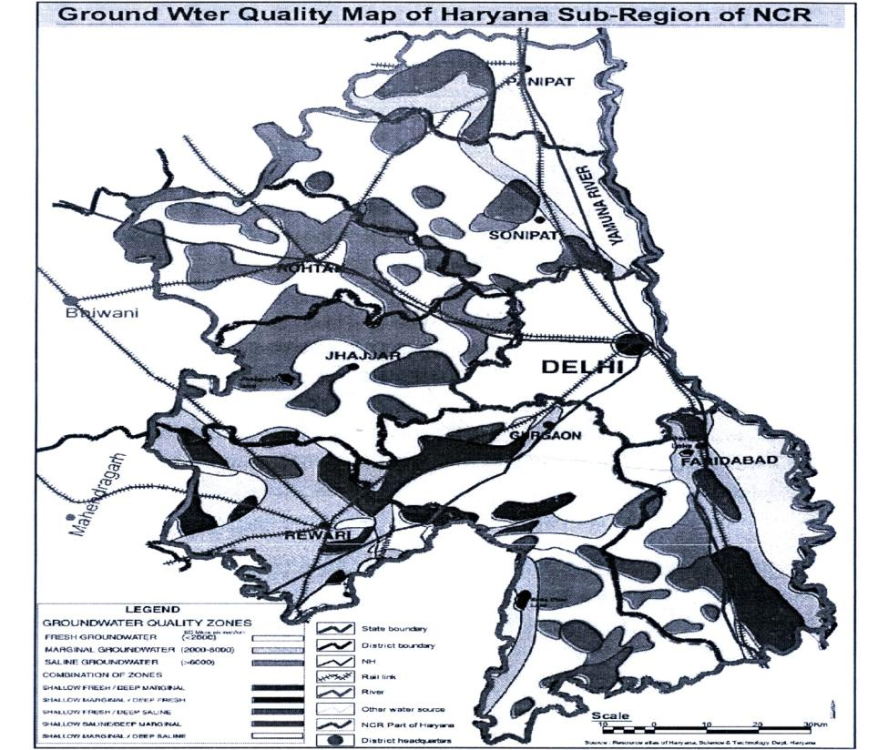
Source: Resource atlas of Haryana, Science & Tech. Dpt., Haryana
2.3.4.v Flora and Fauna
The forests confer manifold ecological benefits on the State economy. They have great bearing on ground water occurrence, soil erosion, floods and environment. They supply a variety of raw material to many industries. Forests are source of revenue to the Government and provide employment to a large number of people. The forests in Haryana are classified under Reserved Forests, Protected forests, un-classed forests, closed U/S 38 of IFA (Indian Forest Act) and Areas closed U/S 4 & 5 of LPA (Land Preservation Act). Major reserved and protected forest areas in Haryana state are mainly confined to the Himalayan ranges in Panchkula and Yamunanagar districts. Small reserved forests are found at a number of places in the districts of Yamunanagar, Kaithal, Ambala, Jind and Hissar. Majority of forests in the State belong to subtropical dry deciduous category whereas subtropical thorny forests are found only in the Aravalli hills in the southern parts of the State.
Hence in the NCR part of Haryana Sub-Region, it is having very little forest cover. Only in the district of Gurgaon, Rewari, Mewat and Faridabad reserve forest of the region exist. Few patches of forest are also in Rohtak, Jhajjar and Sonipat.
Table 2-4: Division / District Wise Forest Area (in Ha) for the Year 2007-2008
District/  state | Reserved forests | Protected |  |  |  |  | Protected forests total | Un-classed forest | Forests u/s 38 of IFA 1927 | Forests u/s 4&5 of LPA 1900 | Grand Total
 |  | Compact | Road | Rail | Canal | Bandh
Panipat | 0.00 | 15.81 | 967.9 | 295 | 2734.47 | 89.49 | 4102.67 | 0 | 72 | 0 | 4174.67
Sonipat | 0.00 | 0 | 1851.16 | 331.58 | 4573.02 | 316.84 | 7074.60 | 284.4 | 0 | 0 | 7359
Gurgaon | 214.89 | 144.68 | 1010.26 | 142 | 200.83 | 90.50 | 1588.27 | 22.66 | 247.37 | 308.36 | 2381.55
Mewat | 16.19 | 0.37 | 1203 | 0 | 821.68 | 136.27 | 2161.32 | 39.66 | 0 | 1856.70 | 4073.87
Faridabad | 314.24 | 37.78 | 925.14 | 0 | 903.48 | 29.59 | 1895.99 | 92.38 | 0 | 3548.47 | 5851.08
Rewari | 514.04 | 0 | 1678.46 | 26.69 | 1471.57 | 117.51 | 3537.14 | 55.04 | 0 | 0 | 4106.22
Rohtak | 0.00 | 41.20 | 1335.26 | 505.5 | 1917.99 | 198 | 3997.95 | 375.40 | 0 | 221 | 4594.35
Jhajjar | 0.00 | 491.00 | 1294.16 | 146.57 | 1852.19 | 42.42 | 3826.34 | 45.04 | 31 | 0 | 3902.38
Haryana Sub-region | 1059.6 | 730.84 | 10265.34 | 1690.55 | 14475.23 | 1020.62 | 28184.28 | 914.58 | 350.37 | 5934.53 | 36443.12
Figure 2-10: Forest area map with National parks and Wild Life Sanctuary
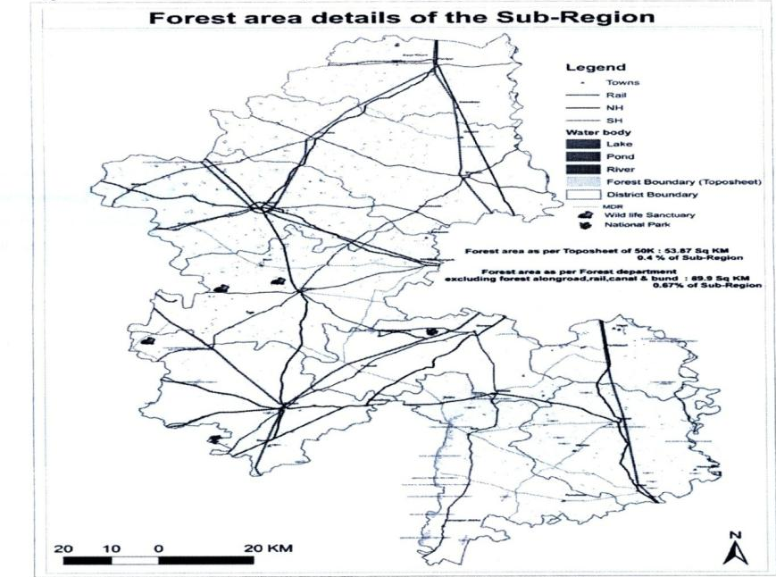
Source: SOI Toposheet 1: 50000 scale; Resource atlas of Haryana 2004
Wildlife constitutes an integral part of the forests. Development of wildlife to a greater extent relies on the type of forests, their density and climate of the region. In Haryana State there are 9 wildlife sanctuaries and 2 national parks out of which there are 3 wildlife sanctuaries and 1 national park in the Haryana Sub-Region covering an area of 1742.55 acres and 359.51 acres respectively consisting of the rate species of birds, black bucks, chital, barking dears, red jungle fowls and leopards etc. The location, spatial extent and wild animals found in these parks and sanctuaries are given in table:
Table 2-5: National parks and wild life century details
National Park/Wildlife Sanctuary | Tehsil/District | Important Wild Animals Found | Area (in acres)
Sultanpur National Park | Gurgaon | Water birds | 359.51
Bhindawas Wildlife Sanctuary | Jhajjar | Water birds, Black buck, Blue bull | 1016.94
Nahar Wildlife Sanctuary | Kosli/Rewari | Black buck, Blue bull, Black and brown partridges | 522.25
Khaparwas Wildlife Sanctuary | Jhajjar | Water bodies | 204.36

These wildlife sanctuaries are under the control of Chief Warden of Ministry of Environment and Forest Govt. Of India and National parks are under the control of The DG Forest MOEF Govt. Of India. No development within the sanctuaries and national parks can be under taken without the consent of the controlling authority. In addition, it is desirable to exercise development control so that no development which can directly or indirectly affect the sanctuaries and the national park. It is desirable to leave 5 km. Buffer zone from the sanctuary and national park border. Since Sultanpur national park is in close proximity to Gurgaon urban area and proposed expansions it is necessary to exercise control to ensure environmentally compatible land use.
2.3.5 Agriculture
Haryana Sub-Region being a part of fertile Indo-Gangetic Plains , the agriculture practice forms the main landuse of the region. There are two main cropping seasons, namely Kharif and Rabi. Majority of the area is utilized for agriculture during Rabi and Kharif (double crop) season due to better irrigation facilities in the region; major Kharif crops include rice, jawar, bajra, gaur, maize, cotton, sugarcane, groundnut and pulses. Rabi crops include wheat, barley, gram rapessed/mustard and pulses. The short period available between mid-May and July is sometimes also used or raising a third crop particularly in the areas where assured irrigation is available for watering the crop during the dry season.
Northern portion of the region is characterized by good agricultural area due to fertile alluvial soils, marginal to food quality of ground water, network of irrigation, canals, tube wells and relatively better natural drainage. On the contrary southern part like Gurgaon and Rewari, due to lack of rainfall, poor irrigation facilities, poor Ground water quality coupled with desertic terrain with and dunes, result in relatively less cultivation during Kharif season.

Figure 2-11: Map showing Cropping Pattern in Haryana Sub-Region
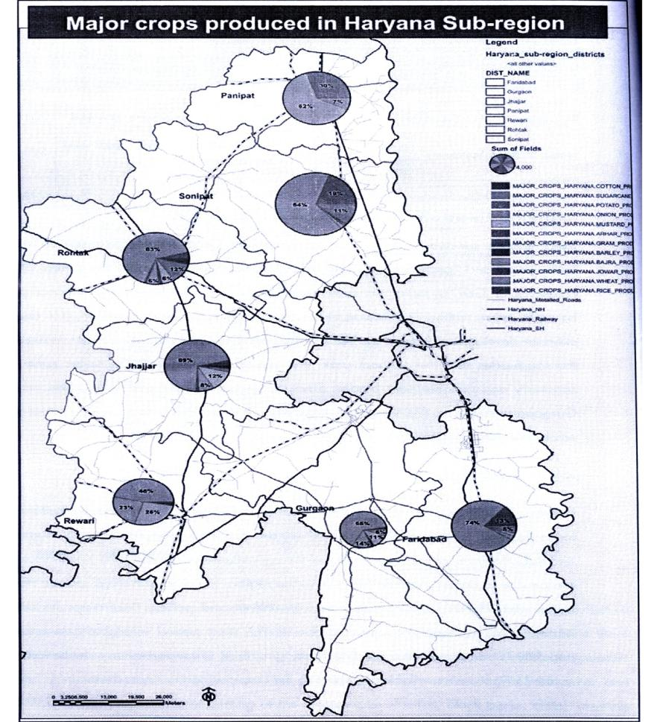
Source: Agriculture department, Haryana 2008
2.3.6 Agro-Ecological Zones of Haryana Sub-Region
Based on the soil, physiography, bioclimate and length of growing period, the State has been divided into 8 agro-ecological zones (NBSS & LUP, 1989). Out of those eight zones our sub region falls under zone-2, zone-3 and zone-4.
Zone 2: These zones cover maximum area of the State extending over parts of Sirsa, Fatehabad, Hisar, Bhiwani and Jhajjar districts. The geomorphology of the region comprises of aeofluvial plain, having hot and dry climate. The annual rainfall varies from 300-450mm with growing period of 60-90 days.
Zone-3: This zone covers southern parts of the State covering districts of Mahendragarh, Rewari and Gurgaon. The topography of the region is represented by rugged hilly terrain of Aravalli ranges. The climate is hot and semi-arid with annual rainfall of about 350-500mm and growing period of less than 90-120 days.
Zone 4: This zone extends over parts of central and eastern Haryana covering districts of Karnal, Kaithal, Panipat, Jind, Rohtak, Sonipat and Faridabad. Topography of the region belongs to alluvial plain with Yamuna alluvial plain covering majority of the areas along the eastern parts of the State. The climate is hot and semi-arid with annual rainfall of 450-600mm and growing period of less than 90-120 days.
Figure 2-12: Agro-Ecological Zones of Haryana Sub-Region
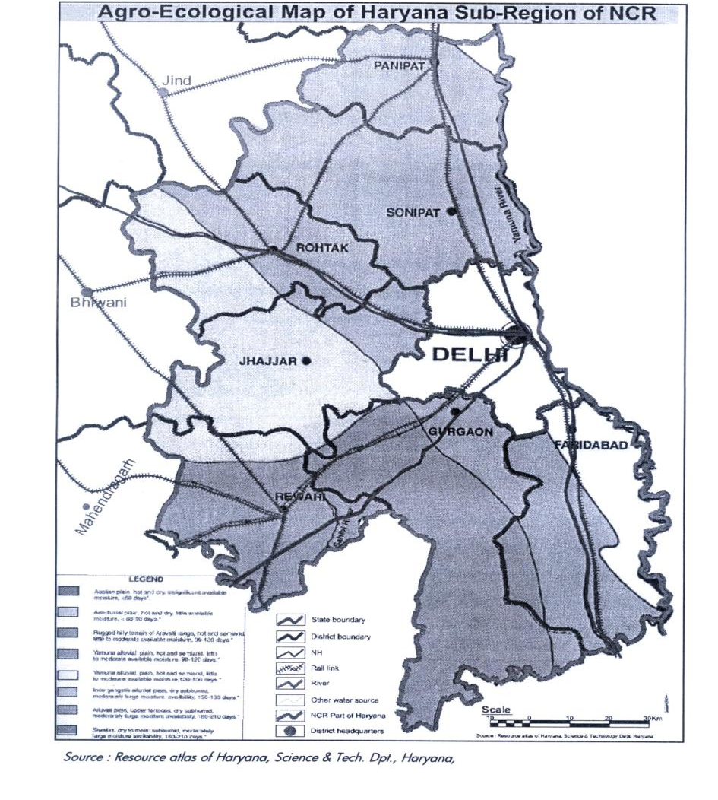

CHAPTER 3 : VISION, OBJECTIVES AND DEVELOPMENT POLICY
3.1 Vision Statement
Vision Haryana Sub region is based on its inherent strength in its and economy which is based on both highly productive agriculture as well as Industrial Development undertaking since the formation of the State. It has got well developed Infrastructure of Educational and health facility as well as Infrastructure of Transportation. The Haryana Sub Region Plan of the National Capital region is covering Eastern part of the State covering area of 13428 km² consisting of district of Panipat, Sonipat, Rohtak, Jhajjar, Gurgaon, Rewari, Mewat, Faridabad and Palwal.
Due to its proximity to the National Capital it is poised to reap the benefit of the unprecedented growth witnessed by the National Capital during the last few Decades. Till now due to enormous attraction of Delhi the immediate hinterland suffered from under development. However, the potential for economic growth cannot be accommodated within the confines of Delhi state anymore. The limitation of physical space and the need to maintain and environmentally satisfying quality of life in Delhi has necessitated evolution of the concept of decentralization of functions in areas surrounding Delhi.
The Sub region of Haryana surrounding Delhi on three sides is a potential natural beneficiary of this growth propensity unleashed by the economic upturn in the country as well as Globalization of the Economy. Globalization and Liberalization of Indian Economy has accelerated investment in the country. Government of Haryana is also in the pursuit of creating an environment for attracting substantial investment. The constrain of space and high cost associated with it are resulting in spill over of economic activities of Delhi which could be by neighbouring State like Haryana. Therefore it is imperative that the sub region prepares itself to receive these opportunities with appropriate physical and social Infrastructures support responding to the investors’ perceptions.
The Regional Plan 2021 for the NCR prepared by NCRPB has provided guidelines for development. In the NCR Plan certain Infrastructure Development was proposed. One of them was an orbital Expressway with a parallel orbital Railway Corridor proposal. This orbital expressway known as KMP Corridor is already under construction by the Govt. of Haryana. A Plan for developing specialized cities on this corridor has already been approved by the Govt. of Haryana. However, the alignment of Orbital Railways has not yet been finalized. It is anticipated during the Plan period this railway will also come about. The advantage of the Orbital Road is that it connects all the National and State Highway radiating out of Delhi. Similarly the Orbital railway connects the entire major railway corridor radiating from Delhi. Proper development of these two transport infrastructure with adequate interface with Local Transport will provide tremendous flexibility in transportation and thus facilitate the most efficient transportation system to help commuting between various urban and activity centre. In addition a Delhi-Mumbai infrastructure corridor is also ensilaged part of which passes through the Southern Portion of the Sub Region connecting Rewari, with Palwal. These two developments have unleashed enormous potential of development whose advantage needs to be taken to ensure optimization of the opportunity offered. In order to study and Plan for a Sustainable future of the Haryana Sub region keeping in view the challenges posed by the threats of Global Climate Change and the Disaster Management Act. The Development Plan of the Sub Region is being prepared keeping in mind the postulates of the NCR Plan as well as the emerging opportunity.
Analysis of existing Land use, on the basis of Remote sensed data, indicates that in the Haryana Sub region of NCR 83.731 of land is under agriculture. Major areas under farms and wasteland, coming 8.38% are mainly located in the Aravalli area & few patches along NH-2 corridor. There are small patches of forests distributed. The KMP corridor covers a portion of the Haryana Sub-region & majority of ecologically sensitive area of the sub-region fall in the corridor.
3.2 Aim and Objectives
3.2.1 Aim
To promote growth and balanced development of the National Capital Region.
3.2.2 Objectives
To achieve the above aim following objectives have been framed:
1. Providing suitable economic base for future growth by identification and development of regional settlements capable of absorbing the economic development impulse of NCT-Delhi.
2. To provide efficient and economic rail and road based transportation networks (including mass transport systems) well integrated with the land use patterns, to support balanced regional development in such identified settlements.
3. To minimize the adverse environmental impact that may occur in the process of development of the National Capital Region.
4. To develop selected urban settlements with infrastructural facilities such as transport, power, communication, drinking water, sewerage, drainage etc. comparable with NCT-Delhi.
5. To provide a rational land use pattern in order to protect and preserve good agricultural land and utilize unproductive land for urban uses.
6. To promote sustainable development in the region to improve quality of life.
7. To improve the efficiency of existing methods of resource mobilization and adopt innovative methods of resource mobilization and facilitate, attract and guide private investment in desired direction.
3.3 Policy for Future Development
The sub-region development plan will attempt to achieve the objectives enumerated earlier. The sub region may be divided into three policy zones.
1. The area abutting Delhi up to the KMP corridor.
2. An arc covering the area from Panipat, Rohtak and Rewari
3. Corridor zones
4. Balance of the area
Considering that Hissar has been identified as a counter magnate for NCR the corridor connecting Delhi, Bahadurgarh, Rohtak and Hissar would need to be emphasized.
The existing corridors viz, Gurgaon-Manesar, Faridabad-Palwal would need to be carefully planned within the parameters of NCR plan. The new corridors viz, KMP, the Western Dedicated Freight Corridor (DFC) connecting Rewari to Palwal would need to be carefully planned to take advantage of the growth potential. Rewari-Rohtak corridor would similarly require extensive planning for exploiting the development potential. The Delhi Mumbai Industrial Corridor (DMIC) being planned along the DFC where specific Investment regions and Industrial areas are being planned by the Govt. of India and the respective State Govt. needs to be incorporated in the Sub regional plan. The Manesar-Bawal Investment region, Rewari-Hissar Investment region, Kundli-Sonipat Industrial area lie in the Haryana sub region. The upcoming Multi-product SEZ promoted by Reliance Industries at Jhajjar also lies in the sub-region. Numerous smaller SEZ and Industrial estates are also being planned.
Areas for conservation, which have been identified in the NCR plan and which are revealed in detailed analysis of land use identifying water resources such as streams, canals, water bodies would be protected against intrusive development and conserved.
Highly productive agricultural land would similarly need protected and conserved. All forest areas in the sub region would be protected and no development would be permitted within one kilometer from the perimeter of the forest. Wasteland reclamation through afforestation would be one of the major concerns of development. Industrial locations would be chosen considering their potential to pollute the environment and industrial zoning atlas as recommended by CPCB would be adopted for choice of location suitability.
3.4 Policy Zones and Sub Zones and their policy
Control over the use of land is essential to protect and conserve vital environmental endowments. The area of concern is:
i) Area where development pressure is high
ii) Area which would have to be protected from built form development, much as ridge, riverbed, wild life sanctuaries, forest etc.
iii) Good quality agriculture land
iv) Areas which are potential for tourism, ecological development etc.
Accordingly four major land use zones have been identified in NCR plan:
i) Controlled/development/regulated zone
ii) Highway corridor zone
iii) Natural conservation zone
iv) Agricultural (rural) zone outside controlled / development / regulated area.
i) Controlled / development / regulated zone
Within the controlled / regulated zones there are three sub zones, whose delineation will be undertaken by the Master / Development plans for the controlled / development / regulated areas the sub zones are:
a) Urbanization areas (including existing Built up / urban areas)
b) Agriculture (rural) zone within controlled / development / regulated areas
c) Green belts
a) Urbanisable area:
The existing & proposed built up areas have to be regulated and guided by Master / Development Plans and local areas plans including Village Development plans within the framework of Regional Plan & Sub-Regional Plans 2021. The density of population has been prescribed as the following
Table 3-1: Density permissible in Urbanisable area
Sl.No. | Urban Centres | Person Per Ha
a) | Below 50,000 | 60 – 80
b) | 50,000 to 1,00,000 | 80 – 100
c) | 1,00,000 to 5,00,000 | 100 – 125
d) | 5,00,000 to 10,00,000 | 125 - 150

The NCR plan stipulates that no proposal for development should be envisaged in natural conservation zones planned green areas, agriculture area, ground water recharging areas and water bodies. Land should be reserved for (a) disposal of solid waste, (b) utility services, (c) dairy farming, (d) horticulture, (e) inter & intra urban transport system etc.
b) Agriculture (Rural) zone:
Agriculture (rural) zone within the controlled / regulated need to be conserved, so that good agriculture land is not conserved unless inevitable.
c) Green buffers:
Green buffers along the expressways, National Highways, State Highways and Railway lines or around / adjacent to any other area as provided in the regulated zone along major transport corridors and other areas, would be maintained & regulated. These green buffers would be outside the controlled / regulated areas. The width of the green buffers would be based on the following:
(a) Expressway / By pass: 100m
(b) NH: 60m,
© State Highways: 30m
(d) Railway Lines: 30m
The width of green buffers outside controlled area should be 500 meters both side.
ii) Highway corridor zone
Highway Corridor zone: In order to control the large scale urban development along the important highways in the region, outside the controlled / development / regulated zone, a regulatory zone is provided within which necessary planned development can be undertaken. It includes all major roads and highways within the Haryana sub region such as;
NH-1: Delhi to Amritsar
NH-10: Delhi to Rohtak
NH-71: Rohtak to Jind
NH-8: Delhi to Gurgaon and beyond
NH-2: Delhi to Calcutta
Controlled area of 500 meters from the ROW (right of way) is mandatory.
iii) Natural conservation zone
a) Natural Conservation zone:
Following area have been identified as naturally sensitive areas:
Extension of Aravalli ridge in Haryana, forest areas, rivers and tributaries of Yamuna and Sahibi, Sanctuaries, major lakes and water bodies, such as Bhadkal lake, Sultanpur etc. Development needs to be restricted to project the ecology of these areas.
Following areas have to be covered:
(a) Extension of Aravalli ridge, sanctions & other ecologically sensitive areas. The development of this area is to be in accordance with the guidelines of MOEF.
(b) Forest area is to be conserved & more areas brought under forests through afforestation by brings all water lands review of irrigation canals, drains, roads, railway lines and village common lands.
© Area under water bodies, ox-bow lakes & Paleo channels and their surrounding areas all areas, which we ground water rechargeable areas are to be kept face from any construction.
(d) Detailed construction plans are to be prepared for areas shown as Nature conservation in the land use plan 2021.
(e) The monuments/man made heritage sites are to be identified is the development plan of each town.
b) Natural Conservation Zone:
The major natural features, identified as environmentally sensitive areas, are the extension of Aravalli ride in Rajasthan, Haryana and NCT-Delhi, forest areas, the rivers are tributaries of Yamuna, Ganga, Kali, Hindon and Sahibi, sanctuaries, major lakes and water bodies such as Badkal lake, Suraj Kund and Damdama in Haryana Sub-region and Siliserh lake in Rajasthan etc. These areas have been demarcated as Natural Area Conservation Zone in the Regional Plan – 2021. Similarly, ground water recharging areas area such as water bodies, ox-bow lakes and paleo-channels has also been identified.
These areas be further detailed out in the Sub-regional Plans and master / Development Plans and the broad policies for these zones which are as under be incorporated appropriately in them and be further elaborated and implemented.
(i) The extension of the Aravalli ridge, sanctuaries and other ecologically sensitive areas be conserved with utmost care and afforested with suitable species. The development in this area be in accordance with the notifications issued for such areas by the Ministry of Environment and Forests under the Environment (Protection) Act, 1986 from time to time.
(ii) In view of the very low existing forest cover (4.02%), it is imperative to bring more areas under forest so as to maintain the ecological balance in this region. Accordingly, all wastelands identified in the existing Land Use 1999 and proposed Land Use Plan 2021, ROW of irrigation canals, drains, roads, railway lines and village common lands are proposed to be brought under forest cover. The total forest cover proposed to be 10% of the total area of the region.
(iii) The areas under water bodies, ox-bow lakes and paleo-channels and their surrounding areas shown in the Ground Water Rechargeable Areas of NCR Plan 2021 in Figure No.3.1 / Land Use Plan 2021 in Figure No.2.3 are kept free from any encroachment / development to allow free flow of water.
Construction activities for human habitation or for any other ancillary purpose thereto not are permitted. Suitable measures be taken to maintain the water bodies with the minimum flow/water level.
(iv) In the flood prone areas/river beds/banks, no construction or habitation activities are permitted. Flood Protection Plan is prepared by the concerned State Governments/agencies. Policies proposed in the Disaster Management Chapter of para 15.3 are further elaborated in the Sub-Regional Plans, Master/Development Plans and Flood Protection Plans.
(v) Detailed Conservation Plans be prepared for the areas shown as Natural Area Conservation Zone in the Land Use Plan 2021.

Figure – 3-1: Ground water rechargeable areas in NCR
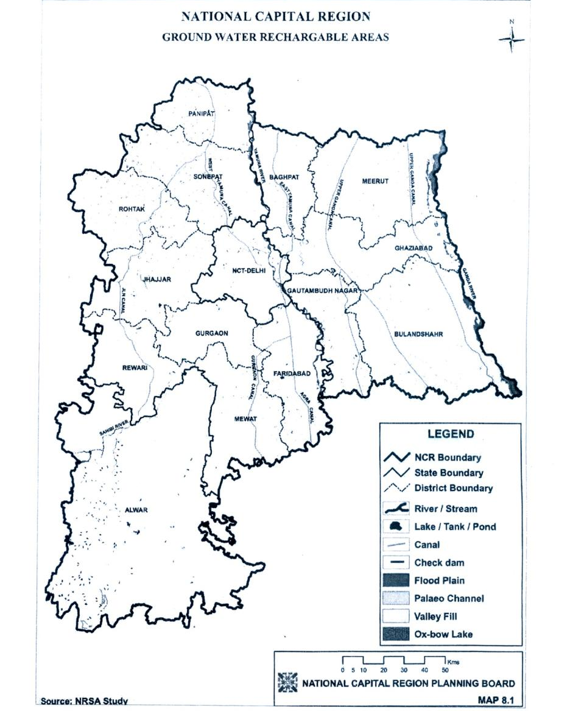
(vi) The monuments / man-made heritage sites and conservation heritage areas be identified in the Master / Zonal Plans of each town and detailed conservation plans be prepared for their protection and conservation.
iv) Agricultural (Rural) Zone outside Controlled/Development/Regulated Areas
Agricultural (Rural) Area of NCR has to be regulated and guided by Village a Block Plans to be drowning under the district planning process. At the regional level, agriculture (rural) zone be designated for primary sector production and as open areas comprising of farmlands, orchards and pastures etc.
The new employment opportunities in non-agriculture sector and consequent concentration of population, the urban expansions would have to be largely made from the agricultural land and other non-urban uses. Therefore, there would be a major impact on land requirements of agriculture sector. In view of this, following policies have been proposed.
(i) Existing cultivated land be conserved for agriculture use as far as possible. Efforts are made to increase the production through intensive cultivation by providing irrigation facilities and other necessary infrastructure.
(ii) Measures be initiated for protection of prime agricultural land and ensure its needless conservation into non-agricultural / urban use.
(iii) Utilization of less and least valuable land for urban expansion/new urban centers / development purpose.
3.5 Zoning Regulations:
Keeping in view rapid urbanization, environmental degradation and to ensure orderly development in the region, a legislative tool in the form of Zoning Regulation is required. In view of this, four broad zones have been identified for application of strict land use control and development and enabling preparation for detailed Plans such as Sub-Regional/Master/Local Area Plans and Master/Development Plans by all respective State Governments. Four broad zones and major activities / uses permitted in these zones are given below:
1. Controlled / Development / Regulate Zone:
(a) Urbanisable Areas (including existing built-up / urban areas)
Within the Urbanizable are proposed in the Master/Development Plan of the respective towns, the functions and uses designated as under be continued:
(i) Residential
(ii) Commercial
(iii) Industrial
(iv) Government offices, public and semi-public
(v) Recreational
(vi) Utility services
(vii) Transport and communications
(viii) Open spaces, parks and playgrounds.
(ix) Graveyards/cemeteries and cremation ghats
(x) Man-made heritage areas
(xi) Natural heritage areas/eco-sensitive areas/conservation areas
The local authority according to the prescribed uses in the Master/Development Plans will govern detailed land uses within the Urbanisable area. The Master/Development Plans of all the towns will be prepared within the framework of the Regional Plan-2021 and Sub-regional Plans. In case any amendment is required in the acts to implement the policies of Regional Plan -2021 that be done by the respective State Governments appropriately.
(b) Agriculture (Rural) Zone within Controlled/Development/Regulated Araes
1) Agricultural, horticultural crops and cash crops
2) Dairy and poultry farming including milk chilling station and pasteurization plants.
3) Social forestry / plantations including afforestation
4) Non-polluting industries registered as RSI/SSU units subject to one of the following conditions:
(i) Located within half kilometer belt encircling the existing village abadi and approachable from a public road/rasta other than scheduled road, national highways and state highways.
(ii) On public road/rasta not less than 30 feet wide other than schedules roads national ghiways and state highways outside the half kilometer zone referred to in above up a depth of 10 meters along the approach road.
5) Non-polluting agro-based industries on public roads/revenue rasta not less than 30 feet wide other than scheduled roads, National Highway and State Highway.
6) The site should not fall within 900 meters restricted belt around defence installations.
7) Land drainage and irrigation by hydro-electric works and tube well for irrigation.
8) Sanitary landfill, compost processing plant and other such activity sites with adequate protected belt as prescribed in the CPHEEO Manual of the Ministry of Urban Development and Poverty Alleviation and the notifications issued by the Ministry of Environment and Forests from time to time.
9) Mining and extraction operations including lime and brick kilns, stone quarries and crushing subject to the rules and approved site.
10) Bus queue shelter and railway station.
11) Airports with necessary buildings
12) Wireless Station
13) Grain godowns, storage spaces at site approved by competent authority
14) Weather station
15) Telephone and electric transmission lines and poles
16) Cremation and buriral grounds
17) Fuel filling station, Service stations and repair workshops
18) Power plant/sub-station/water works/treatment plants and other utility services.
19) Storage godowns for inflammable petroleum products such as LPG, petrol, diesel, kerosene, aviation turbine fuel, light diesel o8il and other petroleum products and lubricants with the approval of the competent authority.
20) Village houses within abadi-deh
21) Farm houses outside abadi-deh, and
22) Expansion of existing village contiguous to abadi-deh including social institutions like schools, dispensaries, veterinary centres and police posts strictly for the requirements of the village and located within 500 meters of the abadi-deh, if undertaken as a project approved or sponsored by the Central Government or State Governments.
23) Recreational/tourist facilities not more than 4.5 meters height, FAR not exceeding 5% of the plot areas.
© Green buffers
i) Approach / service roads
ii) Agriculture and horticulture
iii) Social forestry / plantations including afforestation
iv) Fuel filling stations with amenities like toilets, STD booths small repair shop, small tea/soft drink and snack bar (with no cooking facility)
v) Toll Plaza, bus queue shelters, police booth, first aid centers and telephone booth.
2. Highway Corridor Zone
The Highway Corridor Zone will have to be notified controlled / development / regulated area and Master/Development Plans will have to be prepared by the respective State Governments. In the Highway Corridor Zone (excluding green buffers along highways, activities permitted in ‘Urbanisable area’, ‘agriculture zone within development/controlled/regulated areas’ and the ‘green buffers’ prescribed in paras 17.5.1(a0< 1(b) and 1(c) of Zoning Regulations will be permitted through Master/Development Plans. The competent authority will regulate access to the expressways and highways.
3. Natural Conservation Zone:
In this zone the following uses activities may be permitted:
i) Agriculture and horticulture
ii) Pisiculture
iii) Social forestry/plantations including afforestation
iv) Regional recreational activities with no construction exceeding 0.5% of the area with the permission of the competent authority.
4. Agriculture (Rural) Zone outside Controlled / Development / Regulated Areas
In the agriculture (rural) area zone outside controlled / development / regulated areas the following activities / uses may be permitted in addition to the activities / uses permitted in the “agriculture zone within controlled / development / regulated area’ as indicated:
i) Intensive agriculture and allied activates such as dairying and poultry farming
ii) Afforestation especially on the wastelands and barren lands.
iii) Regional recreational uses such as, regional parks, wildlife sanctuary etc.
iv) Cemeteries, schools, hospitals etc.
v) Quarrying
vi) Brick kilns
vii) Existing village Mandis / agricultural markets
viii) Rural industries

CHAPTER – 4 DEMOGRAPHIC PROFIE
4.1 Demography
4.1.1. Population distribution & density
Population density is defined as number of persons per square kilometer. It is a generalized and easy to understand method knowing the pressure of population on land resources. In 2001, density of population in Haryana was 477 persons /km². This has increased from 372 persons/km² in 1991. In other words, 105 persons/km² has been added in Haryana during 1991-2001. It is immigration from other States to Haryana has contributed towards increase in population pressure on land resources in the State. There are wide inter-district variations in population density. Against the State average of 477 persons/km², it ranged from a high of 1136 persons/km² in Faridabad district to a low of 260 persons/km² in Sirsa district.
In the NCR part of Haryana, average population density is very high i.e. 654 persons/km², much more than the state’s average population density. Located in the close proximity to national capital New Delhi, Faridabad is a highly urbanized and industrialized district in the State. Presence of big industries in the district attracts job seekers to settle in towns. The density of population in Faridabad district is not only very high but also growing fast over the period. Density of population in the district has increased by 333 persons/km², against the State average of 105 persons/km² during 1991-2001.
Table 4-1: District wide demographic details
District | Area (km2) | Total population | Population density (Persons/km²) | Urbanization (%) | Household size
Panipat | 1268 | 967449 | 763 | 40.5 | 5.5
Sonipat | 2122 | 1279175 | 603 | 25.1 | 5.7
Rohtak | 1745 | 940128 | 539 | 35.1 | 5.6
Jhajjar | 1834 | 880072 | 480 | 22.2 | 5.6
Rewari | 1594 | 765351 | 480 | 17.8 | 5.6
Gurgaon | 1254 | 870539 | 694 | 35.6 | 6.1
Faridabad | 1752 | 1990719 | 1136 | 60.8 | 5.6
Mewat | 1859 | 993617 | 534 | 7.1 | 7.5

District | Sex Ratio | %SC | %ST | Literacy rate | Male Literacy rate (%) | Female Literacy rate (%)
Panipat | 829 | 15.79 | 0 | 69.2 | 78.5 | 58.0
Sonipat | 839 | 18.09 | 0 | 72.8 | 83.1 | 60.7
Rohtak | 847 | 19.10 | 0 | 73.7 | 83.2 | 62.6
Jhajjar | 847 | 17.79 | 0 | 72.4 | 83.3 | 59.6
Rewari | 899 | 18.87 | 0 | 75.2 | 88.4 | 60.8
Gurgaon | 873 | 11.32 | 0 | 62.9 | 76.2 | 47.8
Faridabad | 839 | 14.64 | 0 | 72.34 | 83.24 | 59.27
Source: Census 2001, Statistical abstract Haryana 2006-07
Now after the division of Mewat from Gurgaon and Palwal from Faridabad we get the following demographic scenario:

Table 4-2: Demographic details of Gurgaon district

Tehsil | Area (Km²) | Population |  |  |  |  | Literates
Tehsil | Area (Km²) | Total | Male | Female | Rural | Urban | Total | Male | Female
Gurgaon | 738.82 | 629508 | 342527 | 286981 | 380541 | 248967 | 433150 | 258969 | 174181
Pataudi | 177.39 | 100957 | 53193 | 47764 | 67791 | 33166 | 63399 | 38367 | 25032
Sohna | 336.86 | 140074 | 74784 | 65290 | 112504 | 27570 | 80726 | 50735 | 29991
Total | 1253.07 | 870539 | 470504 | 400035 | 560836 | 309703 | 577275 | 348071 | 229204
Source: Census of India 2001, Statistical abstract Haryana 2006-07

Table 4-3: Demographic details of Mewat district

Tehsil | Area (Km²) | Population |  |  |  |  | Literates
Tehsil | Area (Km²) | Total | Male | Female | Rural | Urban | Total | Male | Female
Tooru | 225.19 | 126169 | 67072 | 59097 | 108841 | 17328 | 55833 | 37777 | 18056
Nuh | 463.70 | 212855 | 112553 | 100302 | 201816 | 11039 | 71591 | 52830 | 18761
F.P.Jhirka | 521.50 | 243868 | 128055 | 115813 | 226113 | 17755 | 72567 | 55350 | 17217
Punhana | 290.15 | 206858 | 108267 | 98591 | 193679 | 13179 | 57427 | 44480 | 12947
Total | 1500.54 | 789750 | 415947 | 373803 | 730449 | 59301 | 257418 | 190437 | 66981

Source: Census of India 2001, Statistical abstract Haryana 2006-07

Table 4-4: Demographic profile of Faridabad district

Tehsil | Area (Km²) | Population |  |  |  |  | Sex Ratio | Literacy  Rate (%)
Tehsil | Area (Km²) | Total | Male | Female | Rural | Urban | Sex Ratio | Literacy  Rate (%)
Faridabad | 422.25 | 1178007 | 646425 | 531582 | 115700 | 1062307 | 822 | 78
Ballabhgarh | 320.65 | 187458 | 101248 | 86210 | 187458 | 0 | 851 | 65
Total | 742.90 | 1365465 | 747673 | 617792 | 303158 | 1062307 | 826

Table 4-5: Demographic profile of Palwal district

Tehsil | Area (Sq.Km.) | Population |  |  |  |  | Sex Ratio | Literacy  Rate (%)
Tehsil | Area (Sq.Km.) | Total | Male | Female | Rural | Urban | Sex Ratio | Literacy  Rate (%)
Palwal | 631.94 | 404136 | 217233 | 186903 | 303414 | 100722 | 860 | 65
Hathin | 359.34 | 203867 | 108925 | 94942 | 192951 | 10916 | 872 | 46
Hodal | 376.75 | 221118 | 119232 | 101886 | 173719 | 47399 | 855 | 60
Total | 1368.03 | 829121 | 445390 | 383731 | 670084 | 159037 | 862

Source: Census of India 2001, Statistical abstract Haryana 2006-07

Therefore after the re-division of Faridabad and Mewat into Faridabad, Mewat and Palwal district, now Haryana sub-region is comprised of nine districts whose demographic profile is described in below table.

Table 4-6: Population details of all districts of Haryana Sub-Region

Tehsil | Area (Sq.Km.) | Population |  |  |  |  | Sex Ratio
Tehsil | Area (Sq.Km.) | Total | Male | Female | Rural | Urban | Sex Ratio
Panipat | 1268 | 967449 | 528860 | 438589 | 575369 | 392080 | 829
Sonipat | 2122 | 1279175 | 695723 | 583542 | 957800 | 321375 | 839
Rohtak | 1745 | 940128 | 509038 | 431090 | 610524 | 329604 | 847
Jhajjar | 1834 | 880072 | 476475 | 403597 | 684975 | 195097 | 847
Rewari | 1594 | 765351 | 403034 | 362317 | 629177 | 136174 | 899
Gurgaon | 1253 | 870539 | 470504 | 400035 | 560836 | 309703 | 873
Mewat | 1501 | 789750 | 415947 | 373803 | 730449 | 59301 | 893
Faridabad | 743 | 1365465 | 747673 | 617792 | 303158 | 1062307 | 826
Palwal | 1368 | 829121 | 445390 | 383731 | 670084 | 159037 | 862
Total | 13428 | 8687050 | 4692644 | 3994406 | 5722372 | 2964678

Source: Census of India 2001, Statistical abstract Haryana 2006-07

Figure 4-1: Population density map

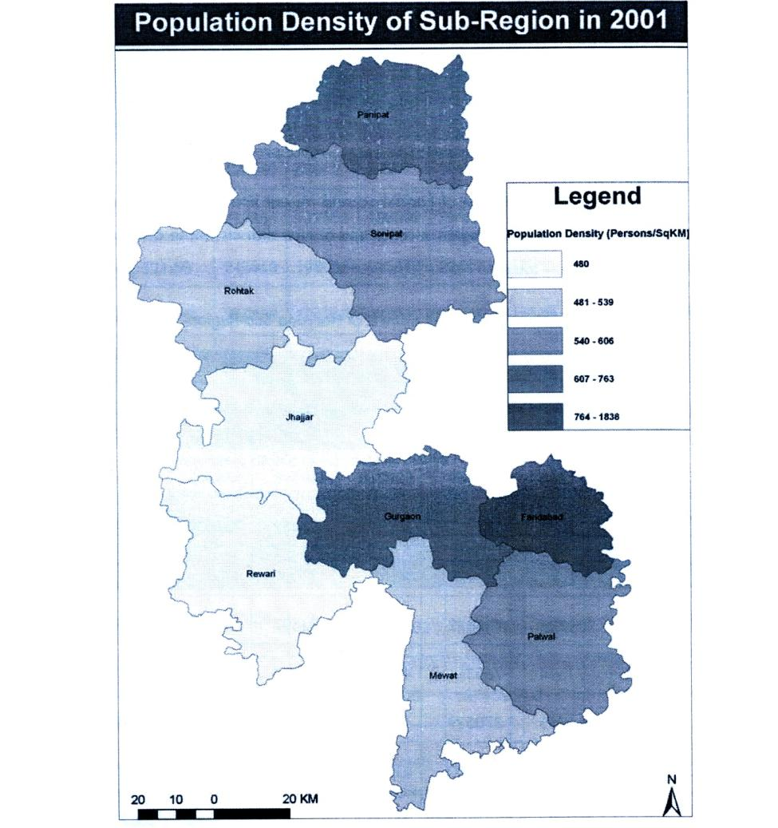
Source: Generated from data of Census of India 2001, Statistical abstract Haryana 2006-07

The Haryana Sub-Region comprises of an area of 13428 sq.km. with a total population of 8.7 million. This amounts to 30.4% area & 41.14% population of Haryana State.

Figure 4-2: Tehsilwise Population density in the Sub-Region, 2001

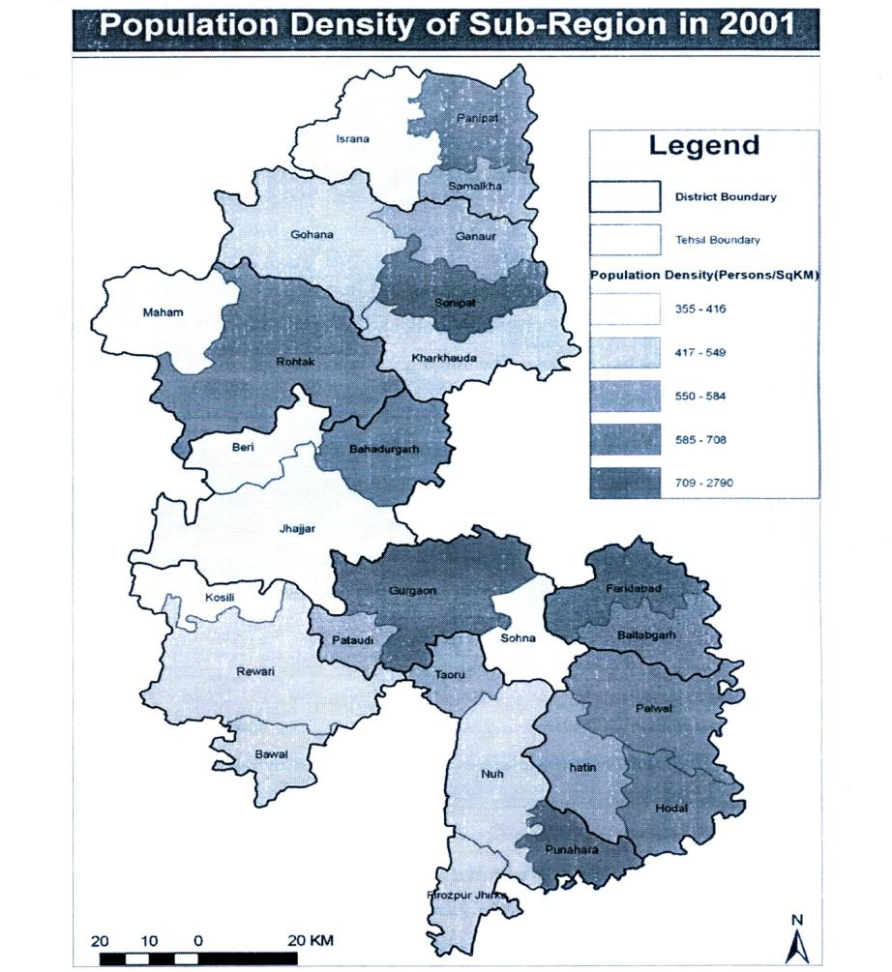
Source: Generated from data of Census of India 2001, Statistical abstract Haryana, 2006-07

The average density of the region (654 persons / km²) is more than the state average of 477 persons / km². The most dense areas within the region is Faridabad followed by Panipat & Gurgaon. The lowest density in the region is that of Jhajjar and Rewari.
In the sub-region there is also great variation of population density within the district, Faridabad tehsil (2790 persons / Sq.Km.) is the most dense tehsil in the sub-region followed by Panipat tehsil (1146 persons /Sq.Km.) and Gurgaon tehsil (852 persons / sq.km.). The least dense tehsil in the sub-region is Maham tehsil (355 persons/Sq.Km.) followed by Israna tehsil (368 persons / Sq.Km.) and Jhajjar tehsil (371 persons / Sq.Km.)
4.1.2 Urbanization level
The average percentage of people living in Urban areas in the region is 34% against the state’s average of 28.9%, which probably means that the region comprises of more urbanized portion of state. The more urbanized districts within the region are that of Faridabad, Panipat and Gurgaon. The lowest Urbanization within the region is observed in Mewat followed by Rewari.
Within the districts also there is great variation in urbanization of tehsil level. Faridabad tehsil (90.18%) is the most urbanized tehsil in the sub-region followed by Panipat tehsil (60.63%), Rohtak tehsil (41.04%) and Gurgaon tehsil (39.55%). The least urbanized tehsil in the sub-region is Israna (0%), Kosli (0%), Ballabhgarh (0%) followed by Nuh tehsil (5.09%)
Figure 4-3: Tehsil wise Urbanization level in the Sub-Region
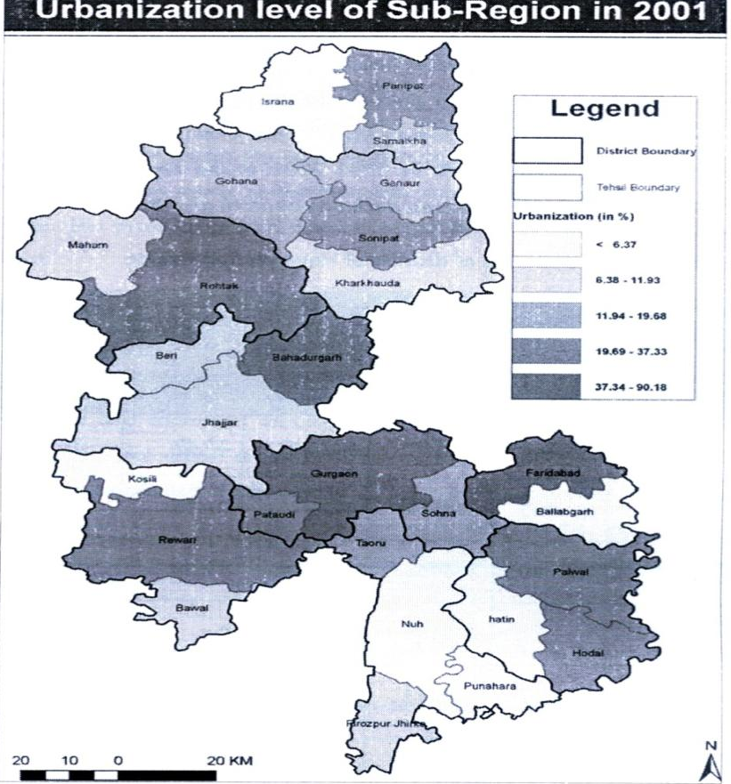
Source: Generated from data of Census of India 2001, Statistical abstract Haryana 2006-07

4.1.3 Gender ratio and Literacy

The Gender ratio within the region varies from 826 to 899, which is quite poor as compared to national average of 933. The average literacy in the region varies from 62.9% to 75.2%, which is quite comparable to the national average of 65%. The female literacy is quite poor in Gurgaon, which needs to be addressed, in order to achieve gender equity.

4.1.4 Population Growth Rate

When we see the population growth trend of the districts of Haryana Sub-Region then we find that since 1981-91 Faridabad district including Palwal district has highest growth rate in the Sub-Region followed by Gurgaon (including Mewat) and Panipat. But in the case of change of growth rate Gurgaon (including Mewat) has shown highest growth rate change from 32.66% in 1981-91 to 44.87% in 1991-2001 in the region, where as Faridabad (including Palwal) and Sonipat has shown declining trend of growth rate.

Table 4-7: Population growth rate of districts of Haryana Sub-Region

Districts | Population |  |  | Growth Rate
District | 1981 | 1991 | 2001 | 1981-91 | 1991-2001
Panipat | 522963 | 698103 | 967449 | 33.49 | 38.58
Sonipat | 821965 | 1045129 | 1279161 | 27.15 | 22.39
Rohtak | 651380 | 776966 | 940128 | 19.28 | 21.00
Jhajjar | * | 715136 | 880072 | * | 23.06
Rewari | 486737 | 610611 | 793312 | 25.45 | 29.92
Gurgaon & Mewat | 863930 | 1146090 | 1660289 | 32.66 | 44.87
Faridabad & Palwal | 996795 | 1493199 | 2194586 | 49.80 | 46.97

Source: Census of India 2001, Statistical abstract Haryana 2006-07
Note: Population has been taken as per the district boundary as on 1-1-2000

CHAPTER 5: INTEGRATIONOF DEVELOPMENT PLANS OF TOWNS
5.1 Urban population scenario
Haryana is the most urbanized state among the states surrounding the NCT Delhi having 28.9%
average population living in urban area. In the state maximum urban population are concentrated more within the NCR Region of Haryana. The average percentage of people living in the urban areas in the Haryana sub-region is 34% which higher than the states average. The more urbanized districts within the sub-region are Gurgaon, Faridabad and Panipat.
The power conferred by the “Pubjab Scheduled Roads and Controlled areas Restriction of Unregulated Development Act, 196” and “The Haryana Development and Regulation of Urban Areas Act, 1975” results to formulation of various master plans for the urban areas for their proper and controlled development. In the Haryana Sub-Region master plans are not made only for the urban areas but also for those urban area complex whose surrounding areas are not classified by the census as town but their growth and urbanized potential is very high and form an urban complex with their mother town, like Gurgaon-Manesar Complex, Faridabad-Ballabhgarh Complex, Rewari-Dharuhera-Bawel Complex and Sonipat-Kundli Complex.
The population scenario of various urban areas/complex is shown in the below table:
Table 5-1: Population scenario of Urban areas as per Master Plans
Population Projection As Per Master Plans
District | Town Name | Class | Pop. 1991 | Pop.2001 | Pop.2011 | Pop.2021
Faridabad | Faridabad* | I | 617,717 | 1,055,938 | 1,750,000 | 2,900,275
Palwal | Palwal | I | 75,127 | 100,722 | 200,721 | 400,000
 | Hodal | III | 25,635 | 38,309 | 57,249 | 85,553
 | Hathin | IV | 7,863 | 10,916 | 20,407 | 38,161
 | Hassanpur | V | 7,130 | 9,090 | 11,589 | 14,774
Rohtak | Rohtak | I | 216,096 | 294,577 | 534,644 | 748,501
 | Maham | IV | 15,083 | 18,174 | 29,065 | 51,000
 | Kalanaur | IV | 14,524 | 16,853 | 19,556 | 22,693
Panipat | Panipat* | I | 191,212 | 362,047 | 506,866 | 709,612
 | Samalkha | III | 18,384 | 29,866 | 44,800 | 67,200
 | AsanKhurd | V | - | 8,066 | Included in Panipat | Included in Panipat
Sonipat | Sonipat* | I | 143,922 | 225,074 | 357,990 | 576,364
 | Gohana | III | 32,467 | 48,518 | 82,480 | 148,464
 | Ganaur | III | 20,952 | 29,006 | 55,109 | 107,462
 | Kharkhoda | IV | 13,151 | 18,763 | 46,907 | 125,000
Gurgaon | Gurgaon* | I | 135,884 | 228,820 | 920,127 | 3,700,000
 | Sohna | III | 16,348 | 27,570 | 76,230 | 167,706
 | Farrukhnagar | V | 8,046 | 9,521 | 11,266 | 13,332
 | Haileymandi | IV | 13,263 | 17,081 | 22,000 | 28,336
 | Pataudi | IV | 11,278 | 16,085 | 22,941 | 32,719
 | Dundahera | IV | 6,767 | 10,626 | Included in Gurgaon | Included in Gurgaon
Mewat | Tooru | IV | 12,534 | 17,328 | 27,725 | 44,360
 | Punahana | IV | 8,679 | 13,179 | 20,012 | 30,388
 | Nuh | IV | 7,492 | 11,038 | 17,661 | 28,258
 | Ferozepur Jhirka | IV | 12,413 | 17,755 | 28,408 | 46,000
Jhajar | Badaurgarh | I | 57,235 | 132,000 | 198,000 | 300,000
 | Jhajjar | III | 27,693 | 39,002 | 74,034 | 133,261
 | Beri | IV | 14,508 | 16,162 | 18,005 | 20,057
 | Ladrawan | V | - | 8,008 | 10,209 | 13,016
 | Sankhal | V | - | 5,179 | Included in Bahadurgarh | Included in Bahadurgarh
Rewari | Rewari | I | 75,342 | 127,230 | 250,000 | 450,000
 | Dharuhera | IV | 10,848 | 46,853 | 93,706 | 187,412
 | Bawal | IV | 9,010 | 12,144 | 57,500 | 100,000
Total Urban Population |  |  | 1,826,603 | 3,021,500 | 5,565,208 | 11,289,905
Average Urban GR |  |  | 51 | 65 | 84 | 103
Source: Master Plans of various Urban Areas

From the above table it is clearly seen that urban population growth rate is shown very high. It has increase from 65% in 2001 to 103% in 2021. In the case of Gurgaon-Manesar Urban complex, it is very high. It is increasing from 68% in 2001 to 302% in 2011 and 2021 which is a little high.
In the case of controlled are boundary demarcation, Gurgaon has covered approximately all the area of Gurgaon Tehsil and Faridabad has covered all most all the district area. In the case of Jhajjar, Nuh and Tooru the controlled area is much more than the present land use development. Following figure shows the master plan land use pattern of the urban areas in Haryana Sub-Region.

Figure 5-1: Master plans land use map of urban areas
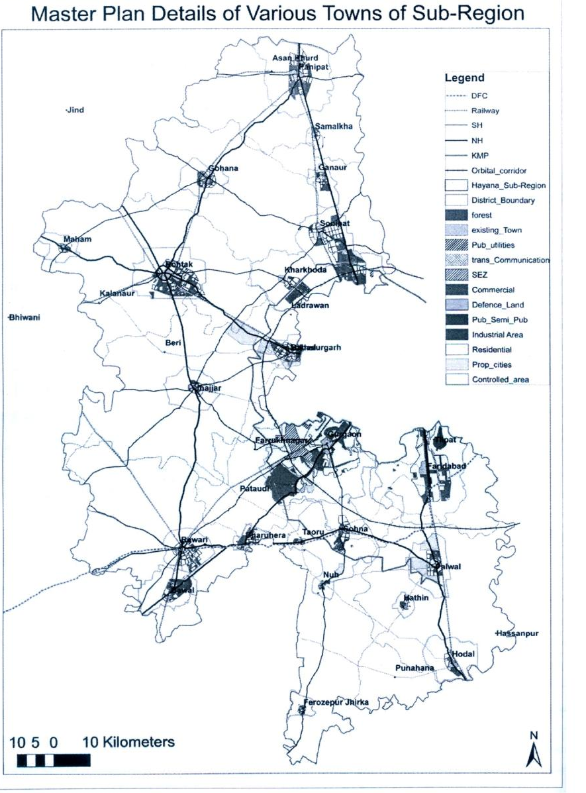
Source: Master plans of various urban areas

5.2 Settlement pattern of Urban Areas
The urban spatial expansion of Delhi, which is the main core of the NCR, has spread into surrounding areas of Haryana and other states. Due to overspill of Delhi’s population, the adjoining areas have also gained tremendous momentum. Then the policy was formulated for restricting the growth of Delhi and allowing only moderate growth in DMA (Delhi Metropolitan Area) towns and inducing development in regional centres around Delhi. But the review of Regional Plan 2001 as well as the results of census 2001 has shown that there had not been any perceptible change in the earlier trends. Then in Regional Plan 2021, strategies for development of settlement system has been adopted to harness the growth impulse of Delhi and to integrate the urban and rural functions in the region.
In the NCR Regional Plan 2021 six tier hierarchy of settlement is proposed. These are as follows:
- Metro Centre : Population more than equals to 10 lakhs
- Regional Centre : Population 3 lakhs to 10 lakhs
- Sub-Regional Centre : Population 0.5 lakhs to 3 lakhs
- Service Centre : Population 10000 to 50000
- Central Village : Population 5000 to 10000
- Basic Village : Population below 5000
Following the above settlement hierarchy as per census 2001 in the Haryana Sub-region, there are one Metro Centre (Faridabad town), one Regional centre (Panipat), six Sub-Regional centres (Palwal, Rewari, Bahadurgarh, Sonipat, Gurgaon and Rohtak), fifty eight Service Centres (38 villages and 20 Towns), two twenty seven Central villages (221 villages and 6 towns) and 2154 Basic Villages. District wise details of the six tier settlement hierarchy is described in below tables (5.2 and 5.3) and figure (5.2):
Table 5-2: District wise details of Settlements

Existing Number of Towns and Villages in 2001 under six tier hierarchy
Districts | Metro | Regional Centre | Sub-Regional Centre | Service Centre |  | Central Villages |  | Basic villages
 |  |  |  | Villages | Towns | Villages | Towns | Basic villages
Panipat | 0 | 1 | 0 | 4 | 1 | 32 | 1 | 144
Sonipat | 0 | 0 | 1 | 4 | 3 | 39 | 0 | 280
Rohtak | 0 | 0 | 1 | 7 | 2 | 42 | 0 | 97
Jhajjar | 0 | 0 | 1 | 5 | 2 | 22 | 2 | 220
Rewari | 0 | 0 | 1 | 0 | 2 | 8 | 0 | 391
Gurgaon | 0 | 0 | 1 | 7 | 4 | 11 | 1 | 253
Mewat | 0 | 0 | 0 | 4 | 4 | 18 | 0 | 401
Faridabad | 1 | 0 | 1 | 1 | 0 | 11 | 1 | 132
Palwal | 0 | 0 | 0 | 6 | 2 | 28 | 1 | 236
Sub-Region Total | 1 | 1 | 6 | 38 | 20 | 221 | 6 | 2154

Source: Census of India 2001

Figure 5-2: Settlement pattern of urban areas of Haryana sub-region

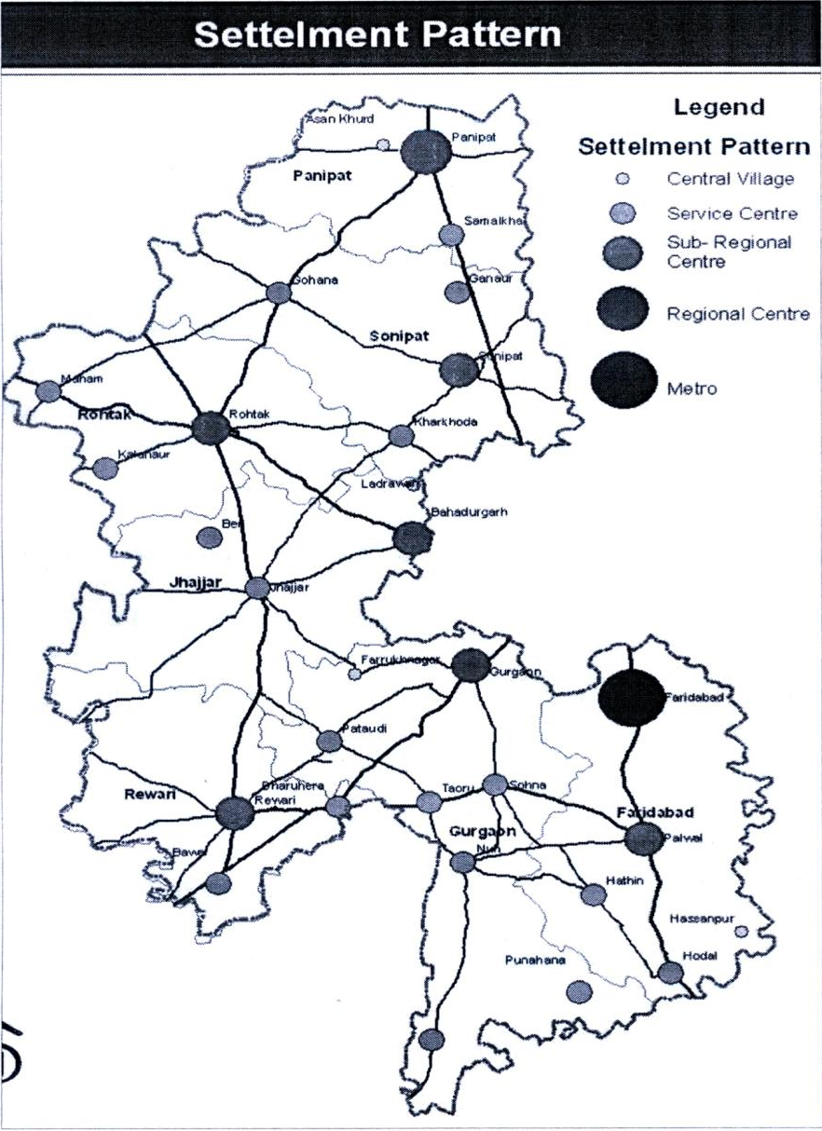
Source: Generated from data of Census of India 2001, Statistical abstract Haryana 2006-07

Considering the six tier hierarchy of settlement we see that only in Faridabad district Metro exists and in Panipat district there is one Regional centre. Except Panipat, Mewat and Palwal all six districts has one Sub-Regional centre. There are 38 villages and 20 towns which fulfil the criteria of Service centres. Gurgaon has the maximum service centres in the Sub-Region. Similarly Panipat has maximum central villages in the Sub-Region. So, in over all Rewari has least number of upper hierarchies of settlement.
Table 5-3: Six tier hierarchy of settlement of towns

Six Tier Hierarchy of Settlement of Towns in 2001 of Haryana Sub-Region
Hierarchy of Settlement | Criteria | Towns
Metro | > 10 Lakhs | Faridabad
Regional Centre | 3 – 10 Lakhs | Panipat
Sub-Regional Centre | 0.5 – 3 Lakhs | Palwal, Rewari, Bahadurgarh, Sonipat, Gurgaon, Rohtak
Service Centre | 10,000 – 50,000 | Dundahera, Hathin, Nuh, Bawal, Punahana, Pataudi, Beri, Kalanaur, Haileymandi, Tooru, Ferizepur, Jhirka, Maham, Kharkhoda, Dharuhera, Sohana, Ganaur, Samalkha, Hodal, Jhajjar, Gohana
Central Village | 5,000 – 10,000 | Sankhal, Tilpat, Ladrawan, Asan, Khurd, Hassanpur, Farrukhnagar
Basic Villages | < 5000 | All 2154 villages

Source: Census of India 2001

CHAPTER -6 TRANSPORTATION
6.1 Road Transportation
Since the formation of Haryana state, there has been a significant growth in the road transportation sector of Haryana. As on year 2001, around 23,000 km of roads connect to villages and cities in Haryana state and with its neighbour states. At present more than 99.88 percentages of villages are connected by metalled roads and road density is around 63.8 km per 100 sq.km. area. Length of different types of roads in Haryana State is as follows:
National Highways : 1,346 km
State Highways : 2,559 km
Major District Roads : 1,569 km
Other District & village roads : 14,730 km.
Other roads : 2,852 km.
Source: Statistical Abstract Haryana, 2006-2007
However, economic development in the state is taking place at very higher rate in comparison to other states of India. This is the reason for large density of vehicles on these available roads. As per the information available for the year 2003-2004, about 5763 motor vehicles accommodated within 100 square kilometer of area. Though, the registered number of vehicles as on 31st March 2004 were 2547,910, in actual about 28,53,667 number of motor vehicles travelled on roads of Haryana state. This shows that a significant percentage of through traffic passes through Haryana state. This large volume of traffic may cause road accidents which results in huge loss of economy and human resources, if proper transportation facilities are not provided. From the statistical information, it is found that about 10,000 vehicles were involved in road accidents in the different part of the state in the year 2006-2007. Unfortunately, 4291 persons died and 8471 persons were injured due to road accidents during this period. The objective of this study is to promote and support the economic development of the region and provide connectivity to all parts of the region, enhance safety and increase the ease of movement of both passengers and goods by decreasing delays.
6.1.1 Existing Road Network and Traffic Characteristics
The existing road network consists of National Highways, State Highways and Major District Roads and Other Roads.
6.1.1.i National Highways
The study area covers 9 districts of Haryana state, cumulatively called as the Haryana Sub-region of NCR in this study. Seven national highways pass through the study area. NH-1, NH-71 and NH-71A connect Haryana state to the northern parts of India while NH-10 connects the study area to the northern parts of Rajasthan. The National Highways NH-2, NH-8 and NH-71B provide connectivity of the study area to central and southern parts of India. Currently National Highway NH-1 (Delhi to Ambala), NH-2 (Delhi to Palwal) and NH-8 (Delhi to Behror) have four lane divided carriageway, whereas NH-10 (Delhi to Rohtak) is partially four laned. Besides, NH-71 (Rewari to Rohtak), NH-71A (Rohtak to Panipat), NH-71B (Rewari-Sohna-Palwal) are two-laned highways. Details of these seven National Highways (NHs) are presented in the Table 6.1.
Table 6-1: Details of National Highways in the Sub-Region of Haryana

NH  No. | Name of Road | Passing through Districts within Sub-region of Haryana | Length (in km.) within Haryana | Current Status (No. of Lanes) | National Highway Development Program (NHDP) | Annual Average Daily Traffic (AADT) in PCUs)
1 | Delhi-Ambala Road (SherShah Suri Marg) | Sonipat,  Panipat | 182 | 4 | 6-lanes by the year 2013 | 45,699
2 | Delhi-Mathura Road | Faridabad,  Palwal | 75 | 4 | 6-lanes by the year 2015 | 58,743
8 | Delhi-Jaipur Road | Gurgaon,  Rewari | 83 | 4 | 6 – lanes by the year 2012 | 87,737
10 | Delhi-Hisar-Dabwali Road | Jhajjar,  Rohtak, | 286 | 2 | 4 lanes by the year 2013 | 26,996
71 | Sangrur-Narwana-Rohtak-Jhajjar-Bawal Road | Rewari,  Jhajjar,  Rohtak | 205 | 2 | 4 – lanes by the year 2013 | 13,835
71-A | Rohtak-Gohana Panipat Road | Rohtak,  Sonipat,  Panipat | 72 | 2 | 4 –leans by the year 2013 | 17,550
71-B | Rewari-Dharuhera-Palwal | Rewari,  Mewat,  Sohna,  Palwal | 76 | 2 | - | 31,743

Source: Details Project Reports and Traffic Reports of Pre/Post tender services of various NH sections, Scott-Wilson India Lvt. Ltd., New Delhi;
www.nhai.org; www.morth.nin.in

Annual Average Daily Traffic (AADT) volume on NH-8 is found to be as high as 87,737 Passenger Car Units (PCUs) per day on Delhi-Gurgaon section of Haryana state in the current year. Similarly, it is found that large volumes of traffic are running over NH-2 and NH-1 sections within Haryana State. Various transportation development initiatives have already been taken by the National Highway Authority of India (NHAI) in the region and many are in pipeline. Some of the important Development projects which will have remarkable impact on the transportation scenario of the region (increase / improve the influx of passengers) are: Conservation of NH-1, 2 and 8 from four lane divided road to six lane divided road in different phases of National Highway Development Program (NHDP) by next six years, and conversion of NH-10, 71, 71-A and 71-B from two lane divided road to four lane divided road by the year 2015.
6.1.1.ii State Highways
State Highways (SH) are the major connectors between State Capital (Chandigarh) and District head quarters. Substantial percentages of traffic in the sub-region are being carried by the State Highways. There are twelve State Highways passing through the Haryana Sub-Region of NCR and details of these roads are presented in the Table 6.2.
Table 6-2: Details of State Highways in the Sub-Region of Haryana

NH  No. | Name of Road | Passing through Districts within Sub-region of Haryana | Length (in km.) within Sub-region of Haryana | Length (in km. ) within Haryana | Annual Average Daily Traffic (AADT) in PCUs)
10 | Gohana-Jind-Barwala-Agroha-Adampur-Bhadra Road | Sonipat | 16.50 | 135.0 | -
11 | Meerut-Sonepat-Gohana-Assandh-Kaithal-Patiala Road | Sonipat,  Paniptat | 86.34 | 175.00 | 36,539
13 | Gurgaon-Sohna-Nuh-Alwar Road | Gurgaon,  Mewat | 88.25 | 95.00 | 25,011
14 | Pankpat-Safidon-Jind-Bhiwani-Loharu Road | Panipat | 24.00 | 195.00 | 8,879
15-A | Jhajjar-Farukhnagar-Gurgaon Road | Gurgaon,  Jhjjar | 40.53 | 45.00 | 16,786
16 | Sanauli-Panipat-Rohtak-Bhiwani Road | Panipat | 18.31 | 62.00 | 39,176
16-A | Gohana-Lakhanmajra-Meham-Chang Road | Sonepat,  Rohtak | 52.00 | 68.00 | 11,282
18 | Rohtak-Kharkhoda-Delhi Border Road | Rohtak,  Sonipat | 42.00 | 42.00 | 33,676
20 | Murthal-Sonepat-Kharkhauda-Sampla-Jhajjar-Chhuchakwas-Jhajjar-Dadri-Loharu Road | Jhajjar  Rohtak,  Sonipat | 82.85 | 160.00 | 6317
22 | Bahadurgarh-Jhajjar-Kosli Road | Rewari,  Jhajjar | 63.72 | 77.00 | 16,288
24 | Rewari-Dahina-Mahendragarh-Satnali-Loharu Road | Rewari | 33.65 | 92.00 | 8,774
26 | Guargaon-Rewari-Narnaul-Singhana Road | Gurgaon,  Rewari | 76.64 | 120.00 | 52,180

Source: P.W.D. (Building & Road Branch), Haryana, 2009

It is observed that more than sixty percent length of these State Highways of Haryana is covered under this study area. Traffic Volume on these SHs are found to be less than traffic volume on NHs in this region; however large volume of traffic are being carried by some roads like SH-11, SH-16, SH-26 etc. The composition of vehicles on SHs is shown in the Figure 6.1.

Figure 6-1: Traffic Composition on SHs
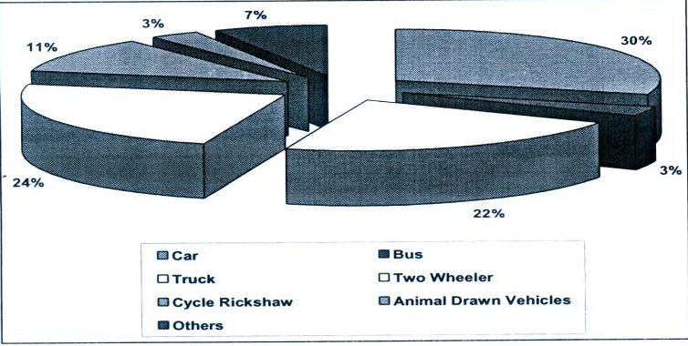
Source: P.W.D. (Building & Road Branch), Haryana, 2009

It is interesting to note from traffic compositions of SHs and MDRs that about 70% of the total vehicles are passenger carrying vehicles and the remaining 30% vehicles are goods vehicles. Cars have a major share among passenger vehicles followed by two wheelers. It signifies that people prefer to use their own private vehicles over public transport in the NCR. Among goods carrying vehicles, truck has a major share. The number of heavy industries which are located in the NCR is less. Hence, major percentages of goods carried as freight are agricultural products and are generally being carried by LCVs and trucks. It can be noticed from Table 6.3 that car traffic is growing at a rate of 12.5 percent per year. Percentage share and growth of car traffic are high which will further bring down the level of service of the road network. In order to improve the quality of service on this road network the use of public transportation facilities need to be encouraged. In order to shift people from private mode of transport to public mode of transport better quality of service on these modes has to be provided. Good quality road and rail network should be provided along with frequent services of good conditioned buses and local trains for promoting the shift of passengers to public transportation facilities.
Table 6-3: Growth Rate of Vehicles on SH and MDR

SL.No. | Vehicle Type | Growth Rate (%)
1 | Car/Jeep/Taxi/Three Wheeler | 12.5
2 | Bus | 8.5
3 | Truck | 14
4 | Two Wheeler | 12.5
5 | Tractor | 5
6 | Cycle Rickshaw | 4
7 | Animal Drawn Vehicles | 4

Source: Statistical Abstract Haryana 2006-07

6.1.1.iii Major District Roads
The other important roads are the Major Districts Roads (MDRs) connecting district head quarters with sub-district head quarters. These roads are important at sub regional level because they act as the main connector to the SHs and MDRs. There are twelve MDRs passing through the study area and are shown in the Table 6.4. The composition of vehicles on MDRs are shown in the Figure 6.2. Both SHs and MDRs in the study area need substantial geometric improvements to accommodate this heavy traffic. All these road sections on which, traffic volume is high and road conditions are not good need to be widened on priority basis, to provide better level of service in the near future.
Table 6-4: Details of Major Districts Roads in the Sub-Region of Haryana

MDR  No. | Name of Road | Passing through Districts within Sub-region of Haryana | Length (in km.) within Sub-region of Haryana | Length (in km. ) within Haryana | Annual Average Daily Traffic (AADT) in PCUs)
121 | Ghanaur-Shahpur Road | Panipat,  Sonipat | 26.00 | 26.00 | 26,997
122 | Bahadurgarh-Chhara-Dhujana-Beri-Kalanaur Road | Jhajjar,  Rohtak | 56.00 | 56.00 | 12,268
123 | Jhajjar-Badli-Delhi Border | Jhajjar | 18.75 | 18.75 | 9,305
130 | Chhuchakwas-Jharli-bahu-Karoli Road | Jhajjar,  Rewari | 36.23 | 36.23 | -
131 | Hodal-Punahana-Nagina Road | Mewat,  Palwal | 40.39 | 40.39 | 26,164
132 | Hodal-Utwar-Nuh-Tooru-Pataudi-Patuda Road | Palwal,  Mewat,  Gurgaon,  Jhajjar | 91.50 | 91.50 | 23,484
133 | Ballabhgarh-Pali-Dauj-Sohana Road | Faridabad,  Gurgaon | 33.00 | 33.00 | 16,268
134 | Palwal-Mandkaul-Nuh Road | Palwal,  Mewat | 32.00 | 32.00 | 17,330
135 | Palwal-Hathin-Utwar-Bhadas Road | Palwal,  Mewat | 37.09 | 42.59 | 21,631
136 | Bahadurgarh-Badli-Chandu Road | Gurgaon,  Jhajjar | 32.50 | 32.50 | 10,649
137 | Mehraul-Gurgaon-Faridabad Road | Faridabad,  Gurgaon | 30.45 | 30.45 | 33,757
138 | GT Road-Jatheri-Akbarpur-Rathdhana-Nahra-Kundal-Sohati-Bahadurgarh Road | Jhajjar,  Rewari | 25.00 | 25.00 | 22,950

Source: P.W.D. (Building & Road Branch), Haryana , 2009

Figure 6-2: Traffic Composition on MDRs
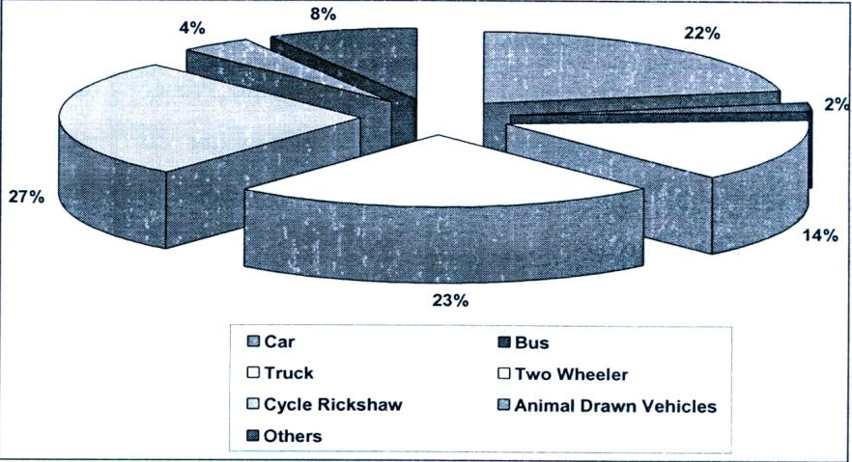
Source: P.W.D. (Building & Road Branch), Haryana, 2009
6.1.2 Development Proposals
Some of the development program in this region includes implementation of theme cities in Kundli-Manesar – Palwal Global Corridor, Proposed Orbital Rail, expansion of Indira Gandhi International airport, proposed Western Dedicated Freight Corridor (W-DFC). In NCR Regional Plan-2021, it is proposed to develop the existing ring road, outer ring road and the five radial roads (National Highways) up to NCR towns (i.e. NH-1 Delhi to Kundli, NH-2 Delhi to Ballabhgarh, NH-8 Delhi to Gurgaon, NH-10 Delhi to Ballabhgarh and NH-24 Delhi to Ghaziabad) as expressways. It is also proposed that all NCR towns should be connected with each other through the Peripheral Expressway consisting of Western Peripheral Expressway (Kundli-Manesar-Palwal (KMP) and Eastern Peripheral Expressway (Faridabad-Noida-Ghaziabad Corridor and Ghaziabad-Kundli Corridor). The Eastern Peripheral expressway (NE2) is under construction. This entire development plan will have impact on overall transportation scenario in the sub-region of Haryana state. All these impacts would need to be analyzed to arrive at a comprehensive transportation policy.
6.2 Railways
Northern Railway plays a major role in India’s industrial and economic development by catering the needs of both Freight and passenger traffic. Presently all rail lines are used by both freight and passenger trains and passenger carrying trains have precedence over freight trains. The freight traffic from Haryana includes mainly food grains, oil seeds and sugar.
6.2.1 Current Status of Rail Network
The Haryana state is currently served by about 1700 route kilometres of rail network. About 93% of the rail length in Haryana state is Broad gauge, 6% is Narrow gauge and the rest is metre gauge. About 35% of rail length of Haryana state is covered under the study area. The rail network can be classified into 3 groups viz;
- Primary rail network/routes
- Feeder routes for primary rail network and
- Other rail sections including those likely to provide alternate routes for part of primary routes.
Figure 6-3: Map below shows the two primary routes and all feeder routes with other rail sections within Haryana sub region.
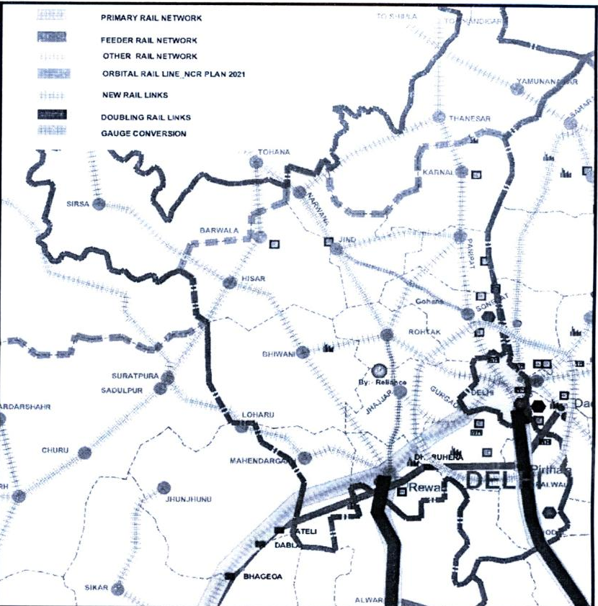
6.2.1.i Primary Rail Network /Routes
There are two primary rail routes between Mumbai and Delhi passing through the Haryana sub region of NCR viz;
- Delhi-Faridabad-Ratlam-Vadodara-JNPT and
- Delhi-Rewari-Phulera-Ahmedabad-Vadodara-JNPT

- Delhi-Faridabad-Ratlam-Vadodara-JNPT (1410 Kms.)
This route comprises the western corridor of Indian Railway’s Golden Quadrilateral and is a highly saturated route, that is dominated by passenger movements. The entire route is double line and electrified. Line capacity on the route ranges from 40 trains to 80 trains each way per day for most of its length. The portion between Mathura and Delhi has a capacity utilization of over 100%. The route being double line and electrified, is faster and more efficient in comparison to the other primary route.
Freight traffic moving on the route comprises Containers, Food grains, Fertilizers, Coal, Iron and Steel and Petroleum products.
The route is already partly over-saturated with a capacity utilization of 140% on Godhra-Ratlam section. The route will require augmentation of capacity for meeting the growing demand of freight and passenger traffic.
II Delhi-Rewari-Jaipur-Phulera-Ahmedabad-Vadodra-JNPT (1405 Kms.)
This route is single line for most of its length and is operated by diesel locomotives.
The portion between Rewari and Phulera has two single track routes, one via Alwar, Bandikui, Jaipur and the other via Ringas. The former route is longer by 65 km as compared to via the Ringas route. The Ringas route has been converted from metre gauge to broad gauge recently (2008-09).
Traffic streams from various feeder routes join at Rewari, Bandikui and Jaipur.
The portion between Rewari and Phulera has a capacity utilization of over 100%. This route being predominantly single line and non-electrified is slower and less efficient in comparison to the other primary route.
90% of traffic moving on this route is likely to get diverted to Western DFC, this amount to 12 trains each way at 2008/08 traffic level. The portions between Palanpur and Beawar, and between Jaipur, Bandikui and Rewari are planned to be doubled, this would increase the capacity by more than one hundred percent. In addition the Phulera – Ringas – Rewari single line broad gauge section will be available for the movement of freight and passenger traffic.
Summarising, a 100 to 150% increase in capacity will be available after completion of on going and sanctioned capacity augmentation works on this route.
6.2.1.ii Congestion on Primary Routes
Presently, due to a lack of adequate line capacity across Palanpur – Ajmer and other single line segments of the primary route J.N. Port – Ahmedabad – Palanpur – Phulera – Jaipur – Rewari, some of the goods traffic originating in Saurashtra region of Gujarat, Pipawaa port, Kandla Port and even Mundra Port for destinations in northern India including Punjab, Haryana and western U.P. is being routed via longer route i.e. i) Viramgam-Geratpur-Anand-Godhra-Ratlam-Tughalakabad. Scrutiny of a sample of originating traffic loadings from three ports, namely Kandla, Pipawawa and Mundra for destinations in Punjab, Haryana and Western U.P. indicated that 35% of freight traffic is being regularly diverted via Godhra-Ratlam. This is traffic which should have been routed via this primary route. Traffic routed via Palanpur for destinations in Punjab is also being moved via Marwar Jn. – Jodhpur – Merta Road – Bikaner – Bhatinda, which is again also longer route when compared to the normal route via Phulera – Rewari – Hissar. These sections providing alternate routes are being improved by upgrading of their signalling systems to handle a greater number of trains.
6.2.2 Feeder routes
There are 2 feeder routes for the two primary routes in Haryana and are listed below:-
- Rewari – Hissar, (142.56 Kms.)
- Rewari-Alwar-Bandikui-Jaipur-Phulera (279.65 Kms.)
The feeder route Rewari – Hissar has surplus capacity available currently, while Rewari-Alwar-Bandikui-Jaipur does not have surplus capacity available. Both of them have more passenger trains than goods trains.
The following two feeder routes in Haryana contribute substantial freight traffic:
- Rewari – Hissar, (142.56 Kms.)
- Rewari – Delhi, (83 Kms.)
6.2.2.i Rewari – Hissar (142.56 Kms.)
This is a non-electrified single line section (Figure 6-3). All rail traffic to/from Ludhiana and Northern Punjab will pass through this section.
Presently the section has capacity of 15 trains per direction per day and 15 trains per day including 9 passenger trains are being run.
Figure 6-4: Rewari – Hissar Link
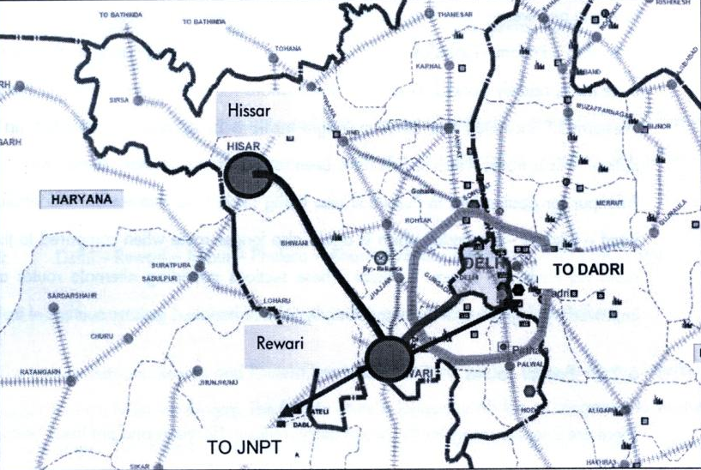
6.2.2.ii Rewari – Delhi, (83 Kms.)
This is a non-electrified double line section (Figure 6-6). Presently the section has capacity for 50 trains per direction per day and 20 trains per day including 15 passengers trains are being run. Freight trains to/from Western DFC would involve a change of traction at the exchange point near Rewari. As the ICDs at Patli and Garhi Harsaru are only 35-40 Kms. from Rewari, a change of traction at the exchange point will cause an increase in the transit time. The section has substantial commuter traffic and there are demands for its electrification and the introduction of EMU commuter train services. The section therefore needs to be electrified and provided with Automatic Block Signalling system.
Figure 6-5: Rewari – Delhi Link
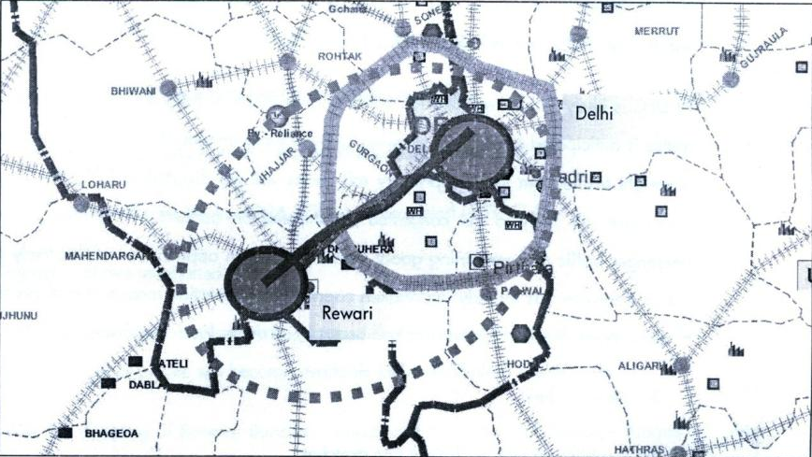
6.2.3 Other Rail Sections
In other rail sections, only those sections which are likely to provide alternate routes for primary routes have been reviewed with a view to assessing their potential for handling additional traffic if required. This includes:-
- Rewari – Ringas – Phulera, (215.12 Kms.)
Bhildi-Samdari along with Samdari-Merta Road and Merta Road – Phulera and Phulera – Ringas – Rewari provide an alternate route for Palanpur-Phulera segment of primary route J.N.Port – Palanpur-Phulera-Rewari-Delhi. Currently these routes have sufficient capacity to cater existing demand.
6.2.4 Ongoing Development of Rail Infrastructure
In view of the anticipated national growth in freight traffic to over 1100 million tones in 2011-12, Indian Railways have prepared a blue print for augmentation of line capacity of High Density Network (HDN) routes. There are 7 such routes, which include all the 6 routes of Golden Quadrilateral and its Diagonals, high-density feeder/alternative routes associated with them and, additionally, the Delhi-Guwahati trunk route.
Delhi-Mumbai via Kota-Ratlam section, including the alternative routes of Delhi – Rewari-Phulera-Ajmer-Chittorgarh and Gandhidham-Palanpur-Bhildi-Samdari-Jodhpur-Bhatinda and Panvel-JNPT, are included in these DHN routes.
W-DFC is likely to be available for traffic only in 2016 or later. Traffic on the two primary routes is anticipated to continue growing at 8-10% per annum. Whilst a substantial quantum of freight traffic from the two primary rail routes will get diverted to DFC, the two primary routes are still likely to get congested / saturated on account of the forecast growth in passenger traffic and remaining goods traffic streams. In appreciation of this likely situation, Indian Railways has already undertaken capacity augmentation measures and strengthening of alternate routes. These measures can be grouped under four categories:
- New rail links
- Doubling of existing freight line stretches
- Conversion of Meter/Narrow Gauge to Broad Gauge
- Other Development Works
Development works which will impact traffic flows on the Delhi-Kota route and its feeder rail sections in Haryana include:
- Doubling
- Provision of 4th line between Tughlakabad and Palwal (33.5 Km.) and
- Provision of 3rd line between Palwal and Mathura –Work in progress
Development works which will impact traffic flows on the Delhi-Rewari-Palanpur route and its feeder rail links include:
i) New rail links:
a) Rewari-Rohtak (81.26 Kms.) work in progress
b) Jind-Sonepat (98.9 Kms.)
ii) Doubling:
- Rewari-Alwar-Bandikui-Jaipur (224.9 Kms.)
iii) Gauge Conversions (Metre Gauge to Broad Gauge):-
- Rewari-Delhi (83.0 Kms.) – second line completed in 2007-08
- Rewari-Ringas-Phulera (294.57 Kms.) – completed in 2007-08
Impact of above mentioned works
With the conservation of the Rewari-Ringas-Phulera chord to broad gauge, another 65 km. Shorter single line route will become available between Phulera and Rewari.
With the doubling of Rewari-Bandikui – Jaipur and conservation of Rewari-Ringas-Phulera to broad gauge, there will be more than a 100% increase in line capacity on the stretch between Phulera and Rewari.
With the conversion of Phulera-Ringas-Rewari sections to broad guage, the line capacity on the route will increase by more than 100%.
Development Proposals
Some of the development proposals in this region include proposed Western Dedicated Freight Corridor (W-DFC), Proposed Orbital Rail etc.
Western DFC
Presently all rail lines are used by both freight and passenger trains and passenger carrying trains have precedence over freight trains. With shared tracks, it will be difficult to meet the growing demand for freight traffic. In order to meet the long term growing demand of freight traffic in an efficient manner, Dedicated Freight Corridors (DFC) have been planned for the exclusive movement of freight traffic along the four sides and two diagonals of the Golden Quadrilateral formed by the four metropolises, namely, Delhi, Mumbai, Chennai and Kolkata. Figure on next page shows the proposed DFC lines.
Of Key interest to this study the 1,483 km. Long Western Dedicated Freight Corridor (W-DFC) from Jawaharlal Nehru Port area (Mumbai) to Dadri / Tughlakabad has been sanctioned and is being implemented by the Dedicated Freight Corridor Corporation of India Limited – a Public Sector Undertaking established under Ministry of Railways.
W-DFC has been designated to accommodate for the running of Double Stack Container trains, and also longer and heavier trains of 25-tonne axle load with maximum moving dimensions comparable to world standards and will be with electric traction. Bridges and fixed structures, which will have long design life, will have to be laid on this route for 30-tonne axle load. The loops provided on the W-DFC will need to accommodate double length trains (1,500 meters). Moreover, a Regional Rapid Transit System connecting Gurgaon, Manesar and Bawal is being considered in the development of Delhi Municipal Industrial Corridor in the Haryana Sub-Region.
Industrial activity of the magnitude envisaged in Haryana sub region is bound to increase demand for a faster and reliable passenger transport system connecting various areas of activities. Rail based passenger transport system, by virtue of being space and energy efficient is preferable to road based. Therefore, rail based mass rapid transit system should be provided for meeting with the increase in passenger traffic.
Proposed Orbital Rail
The NCR Regional Plan-2021 has proposed on Orbital rail around Delhi which is somewhat parallel to the upcoming Kundli-Manesar-Palwal expressway. The exact alignment is not known and is yet to be finalized by the Indian Railways. For practical purposes it can be assumed that it is almost parallel to the KMP expressway with a distance of about 0.5 to 1 km. Between them in order to have transition of passengers from road to rail and vice-versa. This orbital rail is to have an active interchange facility with all the radial rail lines that originate from Delhi and run into the Haryana sub-region to provide complete accessibility in region.
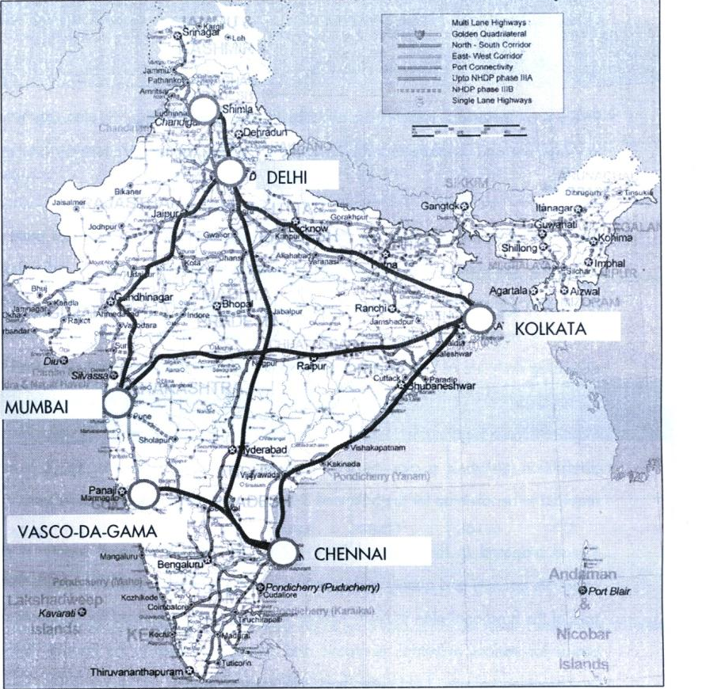

7 POWER
7.1 Background
Power is an important aspect of the physical infrastructure that requires planning in advance, development and management for improvement quality of life, productivity and economic activities.
The status of power supply in the Haryana Sub-region of NCR has not kept pace with the increasing population and the growth of economic activities such as industries, trade, commerce, offices, etc. There is an overall shortage of power in the Northern Grid, from where the region draws its power and hence, power cuts have become a routine affair, disturbing daily life as well as affecting economic productivity. The situation is even worse in the rural areas where the quantity and quality of power supply is very poor. Although augmentation of generating capacities of power and improvement in transmission and distribution system is a gigantic task requiring substantial resources, yet it is essentially required to be taken up for the balanced & harmonized development of the region.
It was proposed in the Regional Plan – 2001 for an uninterrupted supply of power in adequate quantity and quality and priority in making additional power available to NCR. As part of the functional plan in NCR, various strategies were suggested for adequate supply of power for various industrial, economic and business activities in the Priority Towns, which may be at least at par, if not better than Delhi Metropolis.
In the view of Regional Plan – 2001, it was observed that one of the major constraints in the process of planned development and growth of economic activities in the National Capital Region was inadequate availability of electric power. The power supply deficit in Haryana at the end of year 2008-09 was 13.1% in respect of peak demand and 8.5% in respect of energy requirement.
7.2 Existing Power Supply Status:
Peak Power Demand & Demand Met and Energy Requirement & Energy Supplied as in 31.03.2009 in Haryana state is given in the Table 7.1
Table 7-1: Power Supply Position as on 31.03.2009

Power (MW) |  |  | Energy (GWH)
Peak Demand | Peak Demand Met | Deficit % | Requirement | Available | Deficit %
5,511 | 4,791 | 13.1 | 28,791 | 26,331 | 8.5

Source: CEA

Anticipated Peak Power Demand & Demand Met and Energy Requirement & Energy Supplies by the end of 11th plan 31.03.2012 in Haryana state is given in the Table 7.2.

Table 7-2: Anticipated Power Supply Position as on 31.03.2012

Power (MW) |  |  | Energy (GWH)
Peak Demand | Peak Demand Met | Deficit % | Requirement | Available | Deficit %
6,839 | 5,545 | 18.9 | 38,417 | 38,410 | 0
Source: CEA

The details of available capacity in Haryana as on 31.03.2009 are given here under in Table 7.3

Table 7-3: Details of available capacity in Haryana as on 31.03.2009

Sector | Hydro | Thermal | Nuclear | Others | Total
State | 884.2 | 2146.4 | 0 | 62.7 | 3093.3
Private | 0 | 0 | 0 | 6.0 | 6.0
Central | 384.1 | 925.7 | 76 | 0 | 1335.8
Total | 1268.3 | 3072.1 | 76 | 68.7 | 4485.1

Source: CEA

The details of Power Plants anticipated to come up by the end of 11th plan 31.03.2012 is given in Table 7.4

Table 7-4: Details of Power Plants anticipated by end of 11th plan (31.03.2012)

CENTRAL SECTOR
Project Name | Type | Installed Cap  MW | Cap Addition  MW | Haryana Share  MW | Commissioning Date/  Expected D O C
*Parbati Stg-i | H | 800 | 800 | 43 | 2011-12
* Partbati Stg -iii | H | 520 | 520 | 28 | 2010-11
*Chamera iii | H | 231 | 231 | 12 | 2010-11
*Sewa St-ii | H | 120 | 120 | 6 | 2009-10
*Uri-ii | H | 240 | 240 | 13 | 2010-11
*Koldam | H | 800 | 800 | 43 | 2010-11
*Lohari Nagpala | H | 600 | 600 | 32 | 2011-12
*Tapovan V Garh | H | 520 | 520 | 28 | 2011-12
*R Gandhi (Jhajjar) | T | 1500 | 1500 | 750 | 2011-12
*Rampur | H | 412 | 412 | 22 | 2011-12
*Koteshwar | H | 400 | 400 | 17 | 2010-11
RAPP U-5&6 | N | 440 | 440 | 25 | 2008-09
Kahalgaon 6,7 | T | 1000 | 1000 | 23 | 16-03-08 (500)
*Barh St-i | H | 1980 | 1320 | 82 | 2011-12
*Lubansirs Lowe | H | 2000 | 2000 | 40 | 2011-12
*Kameng | H | 600 | 600 | 12 | 2011-12
Total Central Sector |  |  |  |  | 1177
Hisar | T | 1200 | 1200 | 1080 | 2011-12
Jhajjar (CLP) | T | 1320 | 1320 | 1188 | 2010-11
Total State Sector |  |  |  |  | 2268
GRAND TOTAL | T-3115 | H-297 | N-25 | 3437

Source: CEA&HVPNL

District Wise Power Demand & Energy Requirement for the year 2007-08, 2008-09 and April 2009 to August 2009 is given in Table 7.5:

Table 7-5: District Wise Power Demand & Energy Requirement for the year 2007-08, 2008-09 and April 2009 to August 2009

District | (2007-08) |  | (2008-09) |  | April 2009 to August, 2010
 | Energy Consumed  Lakh unit | Peak Demand MW | Energy Consumed Lakh unit | Peak Demand MW | Energy Consumed  Lakh unit | Peak  Demand MW
Sonipat | 13261.55 | 235 | 13672.52 | 242.28 | 6336.17 | 268.27
Rohtak | 15405.59 | 273 | 9542.38 | 169.10 | 4214.94 | 178.46
Jhajjar | 15405.59 | 273 | 8184.84 | 145.04 | 3884.14 | 164.45
Panipat | 14871.92 | 264 | 15682.26 | 277.90 | 7016.26 | 297.07
Faridabad | 27299.66 | 484 | 29504.48 | 522.83 | 14920.24 | 631.72
Gurgaon | 30769.36 | 545 | 34287.07 | 607.58 | 17350.22 | 734.61
Rewari | 16412.53 | 291 | 16041.93 | 284.27 | 7344.17 | 310.95
Total | 118020.61 | 2091 | 126915.5 | 2249.00 | 61066.13 | 2585.54

Source: CEA & HVPNL

Category wise percentage consumption of Haryana is given in Table 7.6:

Table 7-6: Category wise percentage consumption of Haryana

Industries | Domestic | Commercial | Irrigation | Others
26.23 | 20.75 | 5.87 | 40.03 | 7.12

Source: CEA

Figure 7-1: Haryana Sub-Region power supply line

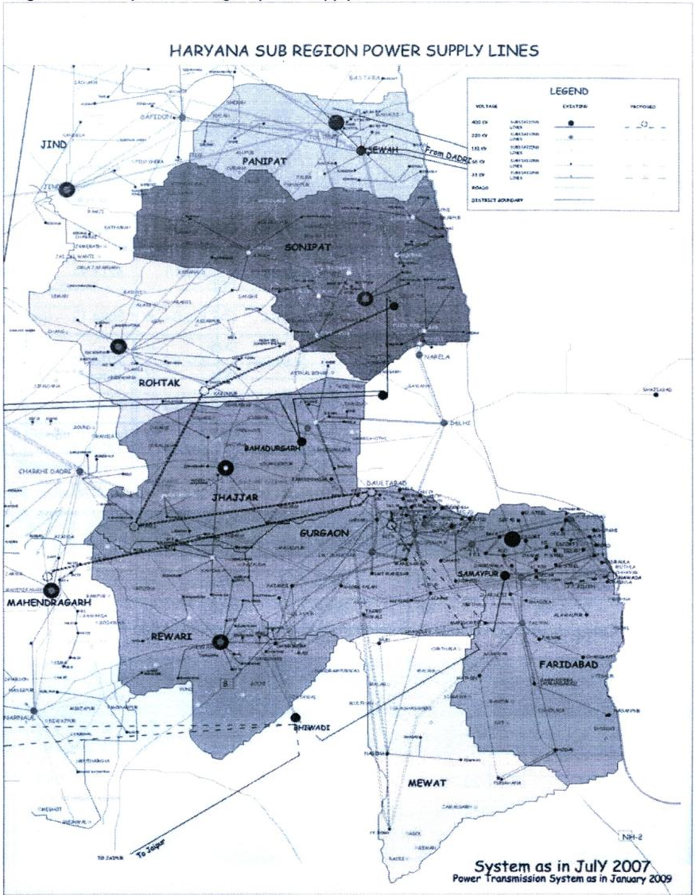
Source: CEA

CHAPTER NO. 8 WATER

8.1 Background
Water is an important resource for meeting the water requirements for irrigation, domestic and industrial uses. In the Sub-Region the ground water is extensively used for irrigation and domestic purpose. Due to tremendous increase in the requirement of ground water for agriculture, industries and by newly developed urban areas, the water levels have shown a continuous declining trend in a number of districts. On the contrary, the excessive use of canal water for agricultural purpose coupled with unfavourable geological conditions, lack of natural surface drainage.
8.2 Planning Parameters
* Area: 13,480 sq.km. – Faridabad, Gurgaon, Rohtak, Sonepat, Rewari, Jhajjar, Panipat & Mewat districts.
* Planning Horizon: 2021
* Integrated regional scheme to augment drinking water supply in the Region.
* Construction of upstream reservoirs to store excess water in monsoon for use in lean period.
* Augmentation of groundwater resources through rain water harvesting
* Protection and reservation of 2-5% area of for water bodies
* Rationalization of water charges so as to cover at least the minimum O&M cost
* Discouraging intensive development of areas of ground water shortage identified by Central Ground Water Board.
* Emphasizing on maintaining quality of water as per the norms set out by the Bureau of Indian Standards.
* Inter basin transfer of water to be encouraged to divert water from water surplus basins to water deficit basins.
* The proposed Sharda Yamuna Link Project for linking river Sharda, atributary of river Ganga with river Yamuna be taken up on top priority so that water requirements of Yamuna sub basins can be met with.
* While considering the requirement for the projected period 2021, it has been assumed that about 25% of the rural population will come under the umbrella of urban areas due to urbanization.
* The norms and standards for water supply as fixed by the Engineer-in-Chief, Haryana PHED.

Urban Settlements
Town/Cities Norm in liters per capita daily (lpcd)
Population 1 lakh & above 200
Population below 1 lakh 135
(This includes demand for commercial areas and floating population)
Rural Settlements
A minimum of 70 lpcd including a supply of 30 lpcd for cattle, for independent connections: a minimum of 100 lpcd; for spot sources: a minimum of 40 lpcd which can supplement the piped supply: stand posts in rural areas: 40 lpcd; urban villages; similar to the town with which it is surrounded. Besides this, following aspects may have to be kept in view:
* The bulk requirement of institutional establishments of 20% separately with proper justification.
* Fire fighting requirement to be added to this as per norms in the CPHEEO Water Supply Manual.
* Unaccounted for water (UFW) to be limited to 15%.
8.3 Present Sources of Water & Hydrological Cycle
Presently Haryana Sub-Region receives water from several sources. These can be grouped as
following:
* Rainfall
* Canals originating from
- river run-off schemes (barrages)
- dams as inter basin water transfer canals
- other Inter-basin transfer canals from barrages and
* ground water
* Flood water of river basins
* Dams
* Lakes and Ponds
* Treated sewage for re-cycling
8.3.1 Water Source Identification
8.3.1.i Surface water

Streams
Haryana districts covered under the sub-regional plan, has no perennial rivers. The river Yamuna
flows along its eastern boundary and river Ghaggar along its western boundary. Hence, The Yamuna river with her major canal system and the Ghaggar river are not feasible as surface water
source for the seven districts covered under the sub-regional plan. The Markanda river or Aruna is
a seasonal stream like the Ghaggar, it originates from the lower Shivalik hills and enters Haryana
near Ambala, hence cannot be used. However, all these seasonal streams are selectively used for
irrigation.
The Markanda Stream (ancient name was Aruna), a seasonal stream, it originates from the lower Shivalik hills and enters Haryana near Ambala. During monsoons, this stream swells up into a raging torrent notorious for its devastating power. The surplus water is carried on to the Sanisa lake where the Markanda joins the Saraswati.
Sahibi River
The Sahibi originates in the Mewat hills near Jitgarh and Manoharpur in Rajasthan. Gathering volume from about a hundred tributaries, it reaches voluminuous proportions, forming a broad stream, around Alwar and Patan. On reaching Rohtak it branches off into two smaller streams, finally passing reaching the outskirts of Delhi and flowing into the Yamuna. There are three other rivulets in and around the Mewat hills – Indori, Dohan and Kasavati, and they all flow northwards from the south.
A new canal from Yamuna river has been proposed. An ambitious Rs. 5 crore canal drinking water scheme for Sonipat is among the development projects. Work on this project would begin soon. Once constructed, this canal will supplement the demands of both drinking and irrigation water.
In view of the above, the water supply for potable and other non-potable uses has to depend primarily on ground water and on canal water. The canal-based water supply schemes are mainly implemented in Rewari district.
Canal Water
To cater to the needs and to harness the agricultural potential of the fertile land rulers of different era, got several canals and diversions works (barrages) constructed in Yamuna and Ganga basin. Earliest canal system of NCR, dates back to 1356 A.D., is still in use. The canal systems have been upgraded and expanded over a period of time and now form a network in NCR. There are a few inter-basin water transfer canals which transfer water from Indus basin to Yamuna basin. These are shown in Figure 8-1. These canals primarily supply water in Haryana, NCT Delhi and some parts of Rajasthan. A detailed discussion and estimation of water supplied through the canals flowing through Haryana Sub-region are discussed below.

Major Canals and diversions works
The major irrigation works, diversion works and canal systems in NCR are discussed in this section. The necessary data for the analysis presented here was collected from state irrigation departments of Uttar Pradesh & Haryana.
Major Diversion works and Head works in the Sub-region Haryana
There are several river diversion works from where water is supplied to Haryana sub-region of NCR. There are several head works & regulators that are also used to divert water in different parts of Haryana sub-region of NCR.
Major Canal System in Haryana
The canal network of entire Haryana state is presented in Figures 8.1
Western Jamuna Canal System
To cater to the water needs and to harness the agricultural potential in Yamuna Basin the then Indian Emperor constructed the canal in 1356 AD which is now called Western Jamuna Canal in western region of NCR. Subsequently, these canals were re-shaped and control structures introduced by the then Emperor, in 1626 AD. It was reconditioned in 1819 AD for Delhi Branch Canal and in 1825 AD for Hansi Branch Canal. Subsequently, the engineers of British Government remodeled (probably re-designed) it by 1908 AD and named it as “Western Jamuna Canal (WJC)” system British misspelled “Yamuna” as “Jamuna”). After independence, this network is continuously getting augmented. The most recent additions being Sirsa Branch canal system a few years back.
The districts of Panipat, Sonipat, Rewari, Rohtak and Jhajjar are supplied water through WJC system Part of the drinking water to Gurgaon is supplied through Gurgaon Water Supply Channel (GWS) and Delhi sub-branch canal system. Figure 8-1 presents a complete map of WJC system which caters to irrigation and drinking water needs of several other districts of surface runoff
Ground water:
The Ground water forms the third major source of water for Haryana Sub-Region after rainfall and canals. A detailed analysis and discussion on ground water resources of Haryana Sub-Region is presented in the later and briefly discussed in subsequent sections.
Flood water of river basins and dams:
In addition to these, every year, a significant quantity of flood waters from catchments upstream of Haryana Sub-Region is passed through the natural drainage system of Haryana Sub-Region.
Lakes and Ponds:
There are several lakes, ponds and bunds that contribute to surface storages within Haryana Sub-Region. In addition this, there are small ponds present in every village and town. In addition to capturing surface runoff, lakes also receive canal water that overflow tail clusters of canals. Further during summer months, these ponds are filled by perennial canals for cattle bathing. Several pond storages based minor irrigation schemes have also been developed primarily in Alwar district of NCR.
Figure 8-2: Drainage system of entire Haryana and their share with other states
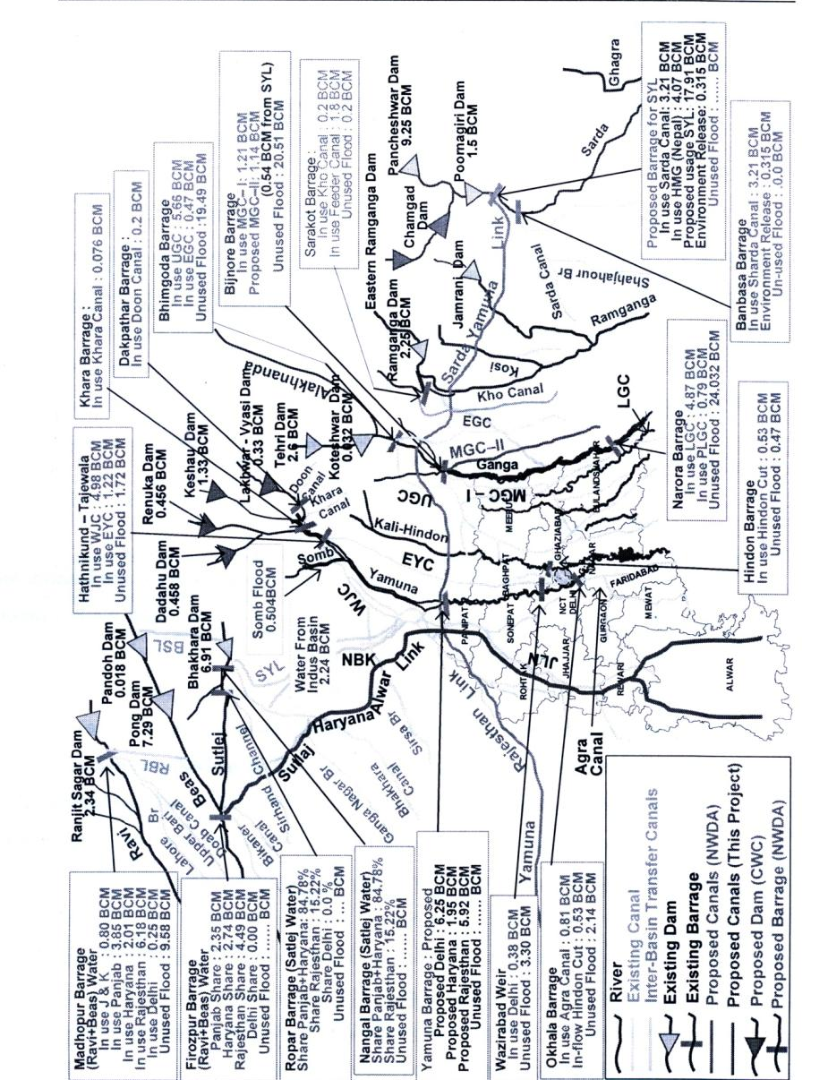

Treated sewage for recycling:
In addition to above, there is a non-conventional source of water that is available in the form of treated sewage (STP locations shown in Figure 8.2. Presently, it is being used for canal irrigation and direct utilization on land for agriculture. Part of this water applied for irrigation percolates deep into the aquifer. There is a threat of ground water contamination if treatment effluent standards are not met.
Figure 8-3: STP Location Map for NCR
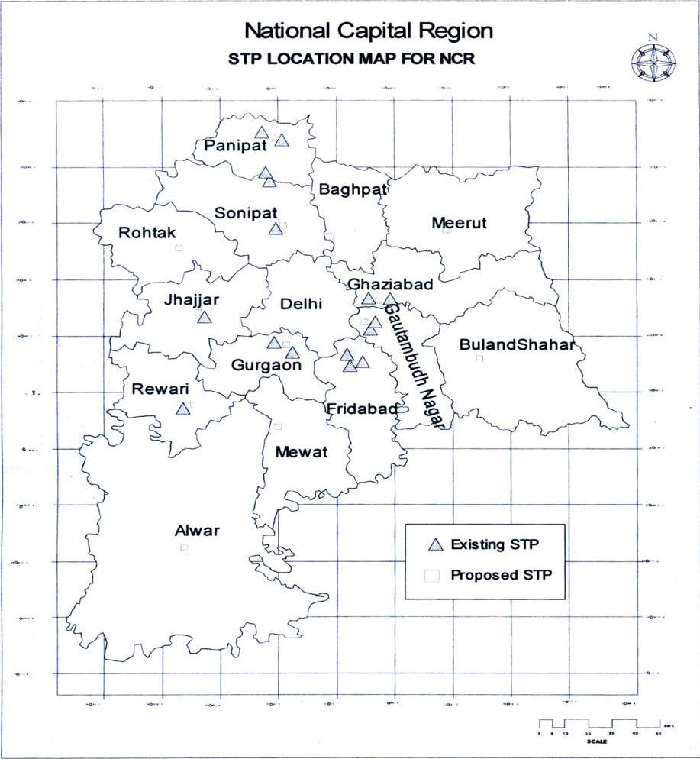

8.3.2 Existing Water Situation
The per capita rate of water supply in urban centers of Haryana Sub-Region ranges from 45 lpcd in Ganaur to 145 lpcd in Panipat. Per capita availability of water in most of the urban centers had dwindled over the last decade due to rapid urbanization and lack of financial and water resources. The status of drinking water supply in rural areas also presents a dismal picture. Moreover, many villages did not have local sources of water and almost equal numbers did not have adequate sources.
Although, there is no estimate available for the ultimate industrial requirement of water up to the year 2021, from secondary data collection, the industrial water demand has been assessed by us and addressed later in this section.
Part demand is also met from ground water. However, entire Haryana Sub-Region has been witnessing decline in ground water levels. The decline has been higher in areas underlain by fresh water as compared to areas having marginal to saline ground water. In the districts of Panipat, Sonepat, Rewari, Rohtak, Faridabad and Gurgaon, the decline in ground water table during the last 20 years was of the order of 3 to 7 meters, the decline being more pronounced in Gurgaon, Faridabad and Rewari Districts. There are several places in southern Haryana where EC values of ground water is greater than 10000 S/cam at 25o C making water non-potable.
Lack of ground water recharging, higher rate of withdrawal, fast pace of urbanization and reduction in run off time for rain water, are the primary causes in retarding the rate of development of ground water. Thus, recharge of groundwater is a priority.
Some of the cities/towns in the region have laid canals/pipe lines to obtain water from the already existing canal system at farther places which has resulted in laying of 3-4 parallel canals/pipes causing duplicity of work and expenditure.
Hence there is a need to adopt regional approach for providing water in the region to examine all the aspects discussed above and prepare a Functional Plan which will lead to preparation of an integrated water supply scheme for the region which is technically viable and suggest sustainable long term measures which may include dams in the Himalayas, inter basin transfer of water, etc.
In addition to above, there are several ongoing and proposed projects from where a significant quantity of water will be available for Haryana Sub-Region in future. An assessment and analysis of scenario after construction of these dams will be discussed later. Similarly, it is also proposed to construct new barrages (Figure 8.1) and inter basin water transfer canals to transfer additional quantity of water to NCR. NCR will also receive a significant quantity of water from Poornagiri and Pancheswar dams on Sarda river via Sarda Yamuna Link and Rajasthan Yamuna Link inter basin link canals. It is also proposed to augment supplies at Okhla weir by proposed Ghaggar Yamuna Link canal through sequential series of command transfer technique. A pre-feasibility study of this canal system has been completed by National Water Development Agency (NWDA). Similarly, Sutlej-Haryana-Alwar Link canal is proposed during the course of this study. There are several sewerage that are also proposed in NCR.
The data on status of water supply for domestic, industrial and irrigation use has been collected for various towns of Haryana Sub-Region from respective PHED and irrigation Department offices in Haryana Sub-Region.
8.3.2.i Domestic water consumption and coverage
The level of service in urban area of Haryana Sub-Region varies from 45 lpcd in Ganaur to 145 lpcd in Panipat. The level of services and population coverage is given in Table 8.1
Table 8.1 Water Supplied and population covered by Govt. Schemes
Sub-Region | Consumption  (in lpcd) |  | Coverage of Population  (% Population)
Sub-Region | Urban | Rural | Urban | Rural
Haryana | 45-145 | 20-100 | 40-100 | 17-100
Source: Department of Irrigation and Agriculture, Haryana
The domestic water supply at present for Haryana Sub-Region has been compiled from Annexure 8.1 respectively and is given in Table 8.2.
Table 8-2: Quantity of domestic water supply
Sub-Region | Unit | Present Water Supplies
 |  | Urban | Rural | Total
Haryana | MLD | 521.46 | 195.04 | 716.50
 | MCM | 190.33 | 71.19 | 261.52
 | BCM | 0.19 | 0.07 | 0.262
Source: Department of Irrigation and Agriculture, PHED Haryana
8.3.2.ii Industrial Water Supply and Coverage
Data on industrial water supply was collected from state PHED and Industrial Departments and
compiled in Annexure-8.1 showing the district wise summary of industrial consumption as per
Year 2009.

8.3.2iii Agriculture water supply/consumption and coverage
Requirement of water for agriculture has been estimated on district basis. Details of agricultural demand are calculated on the basis of average water usage of 2.4 cusecs for 1000 acres of agricultural land. Also the total estimate of irrigation water demand as per Regional Plan 2021 has been adopted. (Source: State Irrigation Department, Haryana)
The crop water requirements are primarily met by rain water and irrigation water supplied by canal systems and tube wells. Data on irrigation water supply was collected from state irrigation departments. The Haryana Sub-Region agricultural water consumed is given in the following Table 8.3.

Table 8-3: Haryana Sub-Region water supplied/consumed for Agriculture
Sub Region | Agriculture consumption in BCW /Year
 | Rain | Irrigation Water (Canal + TW) | Total
Haryana | 2.662 | 2.267 | 4.929
Source: Department of Irrigation and Agriculture, Haryan
8.3.2.iv Recycle of Sewage/Wastewater1
* Objective of recycling
It is estimated that almost 80% of water supplied find it’s way into the sewerage system. With rise in population & depleting water resources, the need for recycling of waste water is becoming more and more important. The treated water can be used for irrigation, wash rooms, air-conditioning of large buildings, flushing of toilets, cooling towers, thermal power plants, motor garages for washing of cars, etc.
* Recycling of waste water in the sample towns:
1. Gurgoan
Amount of waste water generated from STP’s after treatment 98 mld
(30 mld from UASB(PHED) + 68 mld UASB (HUDA)
Newly constructed STP’s (to be commissioned) 50 mld
About 25-30% of treated waste water is being used by near-by farmers for irrigation during non-monsoon season. The balance treated sewage effluent outfalls into Najafgarh drain which ultimately meets river Yamuna.
From newly constructed STP, 10 mld of recycled waste water would be used in Horticulture and the balance would be disposed off in Najafgarh drain.
2. Faridabad
Amount of waste water generated from STP’s after treatment 115 mld
(45 mld UASB + 20mld UASB + 50 mld UASB)
About 25-30% of waste water is being used by the near-by farmer for irrigation during non-monsoon season, the balance is being discharged into Buria nala Agra canal and Gaunchi drain.
3. Panipat
Amount of waste water generated from STP’s after treatment 45 mld
(10 mldUASB (Jatal Road) + 35 mld UASB (Village Siwah)
About 30-40% of waste water is being used by the near-by farmers for irrigating during non-monsoon season, balance treated waste water is discharged into Nohra drain and Panipat drain which ultimately meets river Yamuna.
4. Gohana
There is no sewage treatment plant in operation. One 3.5 mld sewage treatment plant is under construction, hence no recycling of treated waste water at Gohana town. The plant under construction is based on Waste Stabilization Pond technology.
Hence, the total recycled sewage water used for non potable purposes = 10 + (115*O.25) + (45*O.4) = 56.75 MLD
* Observations:
In many of the towns it was observed that the sewerage system was quite old. Many of the joints are leaking and it is a cause of concern because it pollutes the ground water.
It was observed that sewage (with our without treatment) is being discharged in to the nearest river or nala. However during the non monsoon period some sewage is used for irrigation purpose but is limited to small area and for few months only.
Discussions with the agencies concerned revealed that they are aware of the fact that no untreated sewage should be discharged into the river/water courses, but this not followed because of several reasons i.e. insufficient treatment capacity, power breakdown, breakdown of STP, etc. The government agencies were not very receptive to the idea of using the recycled waste water for industrial or non drinking purposes because of the requirement of parallel pipelines & pumping systems, which was considered to be impractical.
8.3.2.v Total water supply
The total water supply for Haryana Sub-Region has been compiled from the Annexure 8.1 and the summarized figures are given in Table 8.4
Table 8.4 Present (Year 2009) water supply in the sub-region of HARYANA
Sub  Region | Unit | Present (Year 2009) supply
 |  | Domestic | Fire Fighting | Industrial | Irrigation | Recycled | Total
Haryana | In MLD | 716.50 | 24.54 | 21.11 | 13504 | 56.25 | 14266
 | In BCM | 0.262 | 0.009 | 0.008 | 4.929 | 0.021 | 5.208
Source: Department of Irrigation and Agriculture, PHED Haryana

CHAPTER 9 – LAND USE
Existing Land use base map is enclosed in the Annexure 9. Its details will be given in the Interim report-II as per the desired work stages listed in the Terms of reference.

TABLE OF CONTENTS
List of Maps
List of Figures
CHAPTER 1: INTRODUCTION
  - BACKGROUND
  - NEED OF NCR PLANNING BOARD
  - PROVISIONS FOR SUB-REGIONAL PLANS
  - SECTION 17 OF NCRPB ACT, 1985
  - SECTION 19 OF NCRPB ACT, 1985
  - SECTION 20 OF NCRPB ACT, 1985
CHAPTER 2: THE REGION
2.1 NATIONAL CAPITAL REGION (NCR) DELHI
2.2 CONSTITUENT AREA OF NCR
2.2.1 GENERAL PROFILE
2.2.2 POLICY ZONES AND LAND USE ZONES
2.3 HARYANA SUB-REGION OF NCR
2.3.1 CONSTITUENT AREA OF HARYANA SUB-REGION
2.3.2 PHYSIOGRAPHY OF THE HARYANA SUB-REGION
2.3.3 GEOLOGY OF HARYANA SUB-REGION
2.3.4 NATURAL RESOURCES
2.3.4.i Waster Bodies
2.3.4.ii Minerals
2.3.4.iii Soils of Haryana Sub-Region
2.3.4.v Flora and Fauna
2.3.5. AGRICULTURE
2.3.6 AGRO-ECOLOGICAL ZONES OF HARYANA SUB-REGION
CHAPTER 3: VISION, OBJECTIVES AND DEVELOPMENT POLICY
3.1 VISION STATEMENT
3.2 AIM AND OBJECTIVES
3.2.1 AIM
3.2.2 OBJECTIVES
3.3 POLICY FOR FUTURE DEVELOPMENT
3.4 POLICY ZONES AND SUB ZONES AND THEIR POLICY
3.5 ZONING REGULATIONS
CHAPTER 4: DEMOGRAPHIC PROFILE
4.1 DEMOGRAPHY
4.1.1 POPULATION DISTRIBUTION & DENSITY
4.1.2 URBANIZATION LEVEL
4.1.3 GENDER RATIO AND LITERACY
4.1.4 POPULATION GROWTH RATE
CHAPTER 5: INTEGRATION OF DEVELOPMENT PLANS OF TOWNS
5.1 URBAN POPULATION SCENARIO
5.2 SETTLEMENT PATTERN OF URBAN AREAS
CHAPTER 6: TRANSPORTATION
6.1 ROAD TRANSPORTATION
6.1.1 EXISTING ROAD NETWORK AND TRAFFIC CHARACTERISTICS
6..1.1.i National Highways
6.1.1.ii State Highways
6.1.1.iii Major District Roads
6.1.2 DEVELOPMENT PROPSALS
6.2 RAILWAYS
6.2.1 CURRENT STATUS OF RAIL NETWORK
6.2.1.i Primary Rail Network/Routes
6.2.1.ii Congestion on Primary Routes
6.2.2 FEEDER ROUTES
6.2.2.I Rewari –Hisar (142.56 Kms)
6.2.2.ii Rewari-Delhi, (83 Kms.)
6.2.3 OTHER RAIL SECTIONS
6.2.4 ONGOING DEVELOPMENT OF RAIL INFRASTRUCTURE

CHAPTER 7 POWER
7.1 BACKGROUND
7.2 EXISTING POWER SUPPLY STATUS
CHAPTER 8 WATER
8.1 BACKGROUND
8.2 PLANNING PARAMETERS
8.3 PRESENT SOURCES OF WATER & HYDROLOGICAL CYCLE
8.3.1 WATER SOURCE IDENTIFICATION
8.3.1.i Surface water
8.3.2 EXISTING WATER SITUATION
8.3.2.i Domestic water consumption and coverage
8.3.2.ii Industrial Water Supply and Coverage
8.3.2.iii Agricultural water supply/consumption and coverage
8.3.2.iv Recycle of Sewage/Wastewater
8.3.2.v Total water supply
CHAPTER 9 LAND USE

LIST OF FIGURES
Figure 2-1: Administrative division of NCR
Figure 2-2: Policy Zones of NCR
Figure 2-3: NCR Land use Zone
Figure 2-4: Haryana Sub-Region Political Map
Figure 2-5: Mineral map of Haryana Sub-Region
Figure 2-6: Soil map of Haryana Sub-Region of NCR
Figure 2-7: Soil fertility map of Haryana Sub-Region
Figure 2-8: District wise Ground water depth
Figure 2-9: Ground water quality of Haryana Sub-Region
Figure 2-10: Forest area map with National parks and Wild Life Sanctuary
Figure 2-11: Map showing Cropping Pattern in Haryana Sub-Region
Figure 2-12: Agro-Ecological zones of Haryana Sub-Region
Figure 3-1: Ground water rechargeable areas in NCR
Figure 4-1: Population density map
Figure 4-2: Tehsilwise Population density in the Sub-Region, 2001
Figure 4-3: Tehsilwise Urbanization level in the Sub-Region
Figure 5-1: Master plans landuse map of urban areas
Figure 5-2: Settlement pattern of urban areas of Haryana sub-region
Figure 6-1: Traffic Composition on SHs
Figure 6-2: Traffic Composition on MDRs
Figure 6-3: Map below shows the two primary routes and all feeder routes with other rail sections within Haryana Sub-Region
Figure 6-4: Rewari – Hissar Link
Figure 6-5: Rewari – Delhi Link
Figure 6-6: Proposed DFC Lines
Figure 7-1: Haryana Sub-Region power supply lines
Figure 8-1: Drainage system of entire Haryana and their share with other states
Figure 8-2: STP Location Map of NCR

LIST OF TABLES
Table 1-1: Population trend of Delhi since 1901
Table 2-1: NCR Constituent descriptions
Table 2-2: Haryana Sub-Region profile
Table 2-3: Ground water depth since 1974 to 2009
Table 2-4: Division/District Wise Forest Area (in Ha) for the year 2007-2008
Table 2-5: National parks and wild life sanctuary details
Table 3-1: Density permissible in Urbanizable area
Table 4-1: District wise demographic details
Table 4-2: Demographic details of Gurgaon district
Table 4-3: Demographic details of Mewat district
Table 4-4: Demographic profile of Faridabad district
Table 4-5: Demographic profile of Palwal district
Table 4-6: Population details of all districts of Haryana Sub-Region
Table 4-7: Population growth rate of districts of Haryana Sub-Region
Table 5-1: Population scenario of Urban areas per Master Plans
Table 5-2: District wise details of Settlements
Table 5-3: Six tier hierarchy of settlement of towns
Table 6-1: Details of National Highways in the Sub-Region of Haryana
Table 6-2: Details of State Highways in the Sub-Region of Haryana
Table 6-3: Growth Rate of Vehicles on SH and MDR
Table 6-4: Details of Major District Roads in the Sub-Region of Haryana
Table 7-1: Power Supply Position as on 31.03.2009
Table 7-2: Anticipated Power Supply Position as on 31.03.2012
Table 7-3: Details of available capacity in Haryana as on 31.03.2009
Table 7-4: Details of Power Plants anticipated by end of 11th Plan (31.03.2012)
Table 7-5: District wise Power Demand & Energy Requirement for the year 2007-08, 2008-09
And April 2009 to August 2009
Table 7-6: Category wise percentage consumption of Haryana
Table 8-1: Water Supplied and population covered by Govt. Schemes
Table 8-2: Quantity of domestic water supply
Table 8-3: Haryana Sub-Region Water supplied/consumed for Agriculture
Table 8-4: Present (Year 2009) water supply in the sub-region of HARYANA

